**VISVESVARAYATECHNOLOGICALUNIVERSITY**

**“JnanaSangama”, Belgaum -590014, Karnataka.**



**LAB RECORD**

# Computer Network Lab (23CS5PCCON)

***Submitted by***

**Dheemanth M (1BM22CS087)**

***in partial fulfillment for the award of the degree of***

## BACHELOROFENGINEERING

***in***

### COMPUTER SCIENCE AND ENGINEERING



**B.M.S. COLLEGE OF ENGINEERING**

**(Autonomous Institution under VTU)**

## BENGALURU-560019

## Academic Year 2024-25 (odd)

**B.M.S. College of Engineering**

**Bull Temple Road, Bangalore 560019**

(Affiliated To Visvesvaraya Technological University, Belgaum)

## Department of Computer Science and Engineering



## CERTIFICATE

This is to certify that the Lab work entitled “ Computer Network (23CS5PCCON)” carried out by **Dheemanth M (1BM22CS087),** who is a bonafide student of **B.M.S. College of Engineering.** It is in partial fulfilment for the award of **Bachelor of Engineering in Computer Science and Engineering** of the Visvesvaraya Technological University, Belgaum. The Lab report has been approved as it satisfies the academic requirements of the above-mentioned subject and the work prescribed for the said degree.

|  |  |
| --- | --- |
| Sandhya A Kulkarni  Associate Professor  Department of CSE, BMSCE | Dr. Kavitha Sooda  Professor & HOD  Department of CSE, BMSCE |

### Index

|  |  |  |  |
| --- | --- | --- | --- |
| **Sl.**  **No.** | **Date** | **Experiment Title** | **Page No.** |
| 1 | 09-10-24 | Create a topology and simulate sending a simple PDU from source to destination using hub and switch as connecting devices and demonstrate ping messages. | 4-8 |
| 2 | 09-10-24 | Configure IP address to routers in packet tracer. Explore the following messages:  ping responses, destination unreachable, request timed out, reply. | 9-11 |
| 3 | 16-10-24 | Configure default route, static route to the Router (Part 1). | 12-14 |
| 4 | 23-10-24 | Configure default route, static route to the Router (Part 2). | 15-17 |
| 5 | 13-11-24 | Configure DHCP within a LAN and outside LAN. | 18-22 |
| 6 | 20-11-24 | Configure RIP routing Protocol in Routers . | 23-25 |
| 7 | 20-11-24 | Demonstrate the TTL/ Life of a Packet. | 26-28 |
| 8 | 27-11-24 | Configure OSPF routing protocol. | 29-31 |
| 9 | 18-12-24 | Configure Web Server, DNS within a LAN. | 32-33 |
| 10 | 18-12-24 | To construct a simple LAN and understand the concept and operation of Address Resolution Protocol (ARP). | 34-36 |
| 11 | 18-12-24 | To understand the operation of TELNET by accessing the router in the server room from a PC in the IT office. | 37-39 |
| 12 | 18-12-24 | To construct a VLAN and make the PC’s communicate among a VLAN. | 40-43 |
| 13 | 18-12-24 | To construct a WLAN and make the nodes communicate wirelessly. | 44-46 |
| 14 | 18-12-24 | Write a program for error detecting code using CRC-CCITT  (16-bits). | 47-48 |
| 15 | 18-12-24 | Write a program for congestion control using Leaky bucket algorithm. | 49-50 |
| 16 | 18-12-24 | Using TCP/IP sockets, write a client-server program to make the client send the file name and the server to send back the contents of the requested file if present. | 51-52 |
| 17 | 18-12-24 | Using UDP sockets, write a client-server program to make client sending the file name and the server to send back the contents of the requested file if present. | 53-54 |
| 18 | 18-12-24 | WIRESHARK | 60-62 |

Github Link:  [LINK](https://github.com/dheemanthm04/CN-Lab)

#### Program 1

**Aim:** Create a topology and simulate sending a simple PDU from source to destination using hub and switch as connecting devices and demonstrate ping messages.

**Topology , Procedure and Observation:**

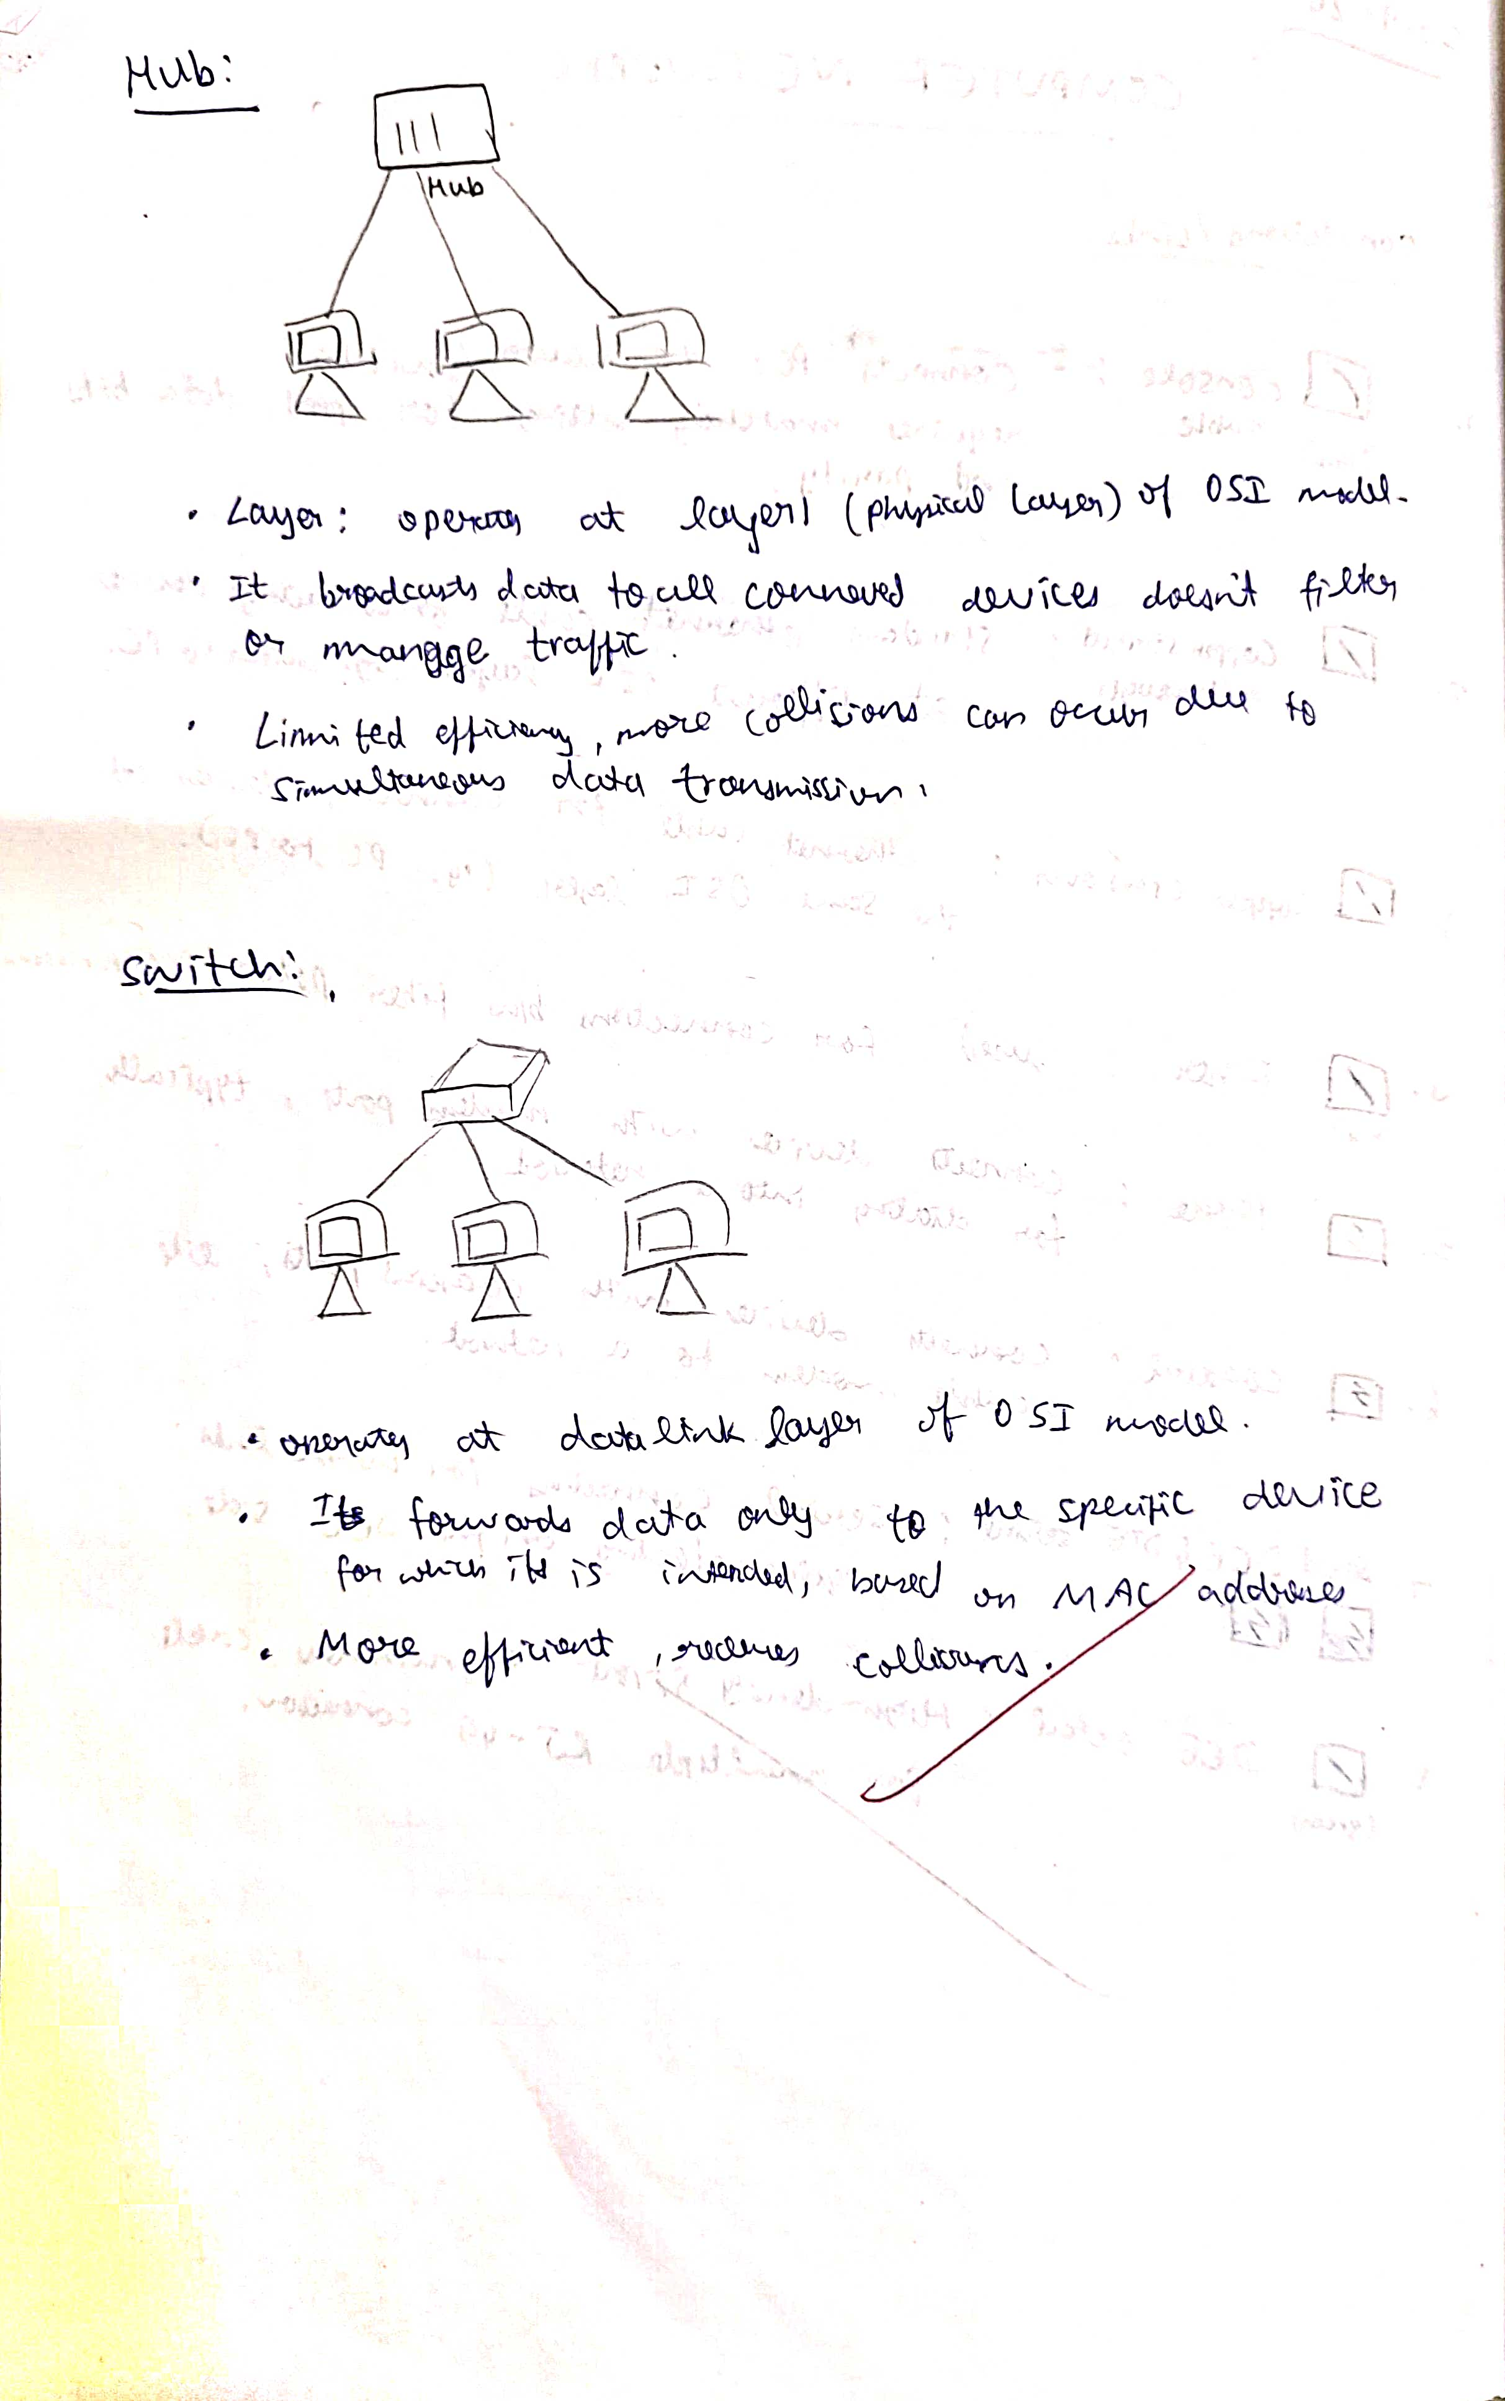

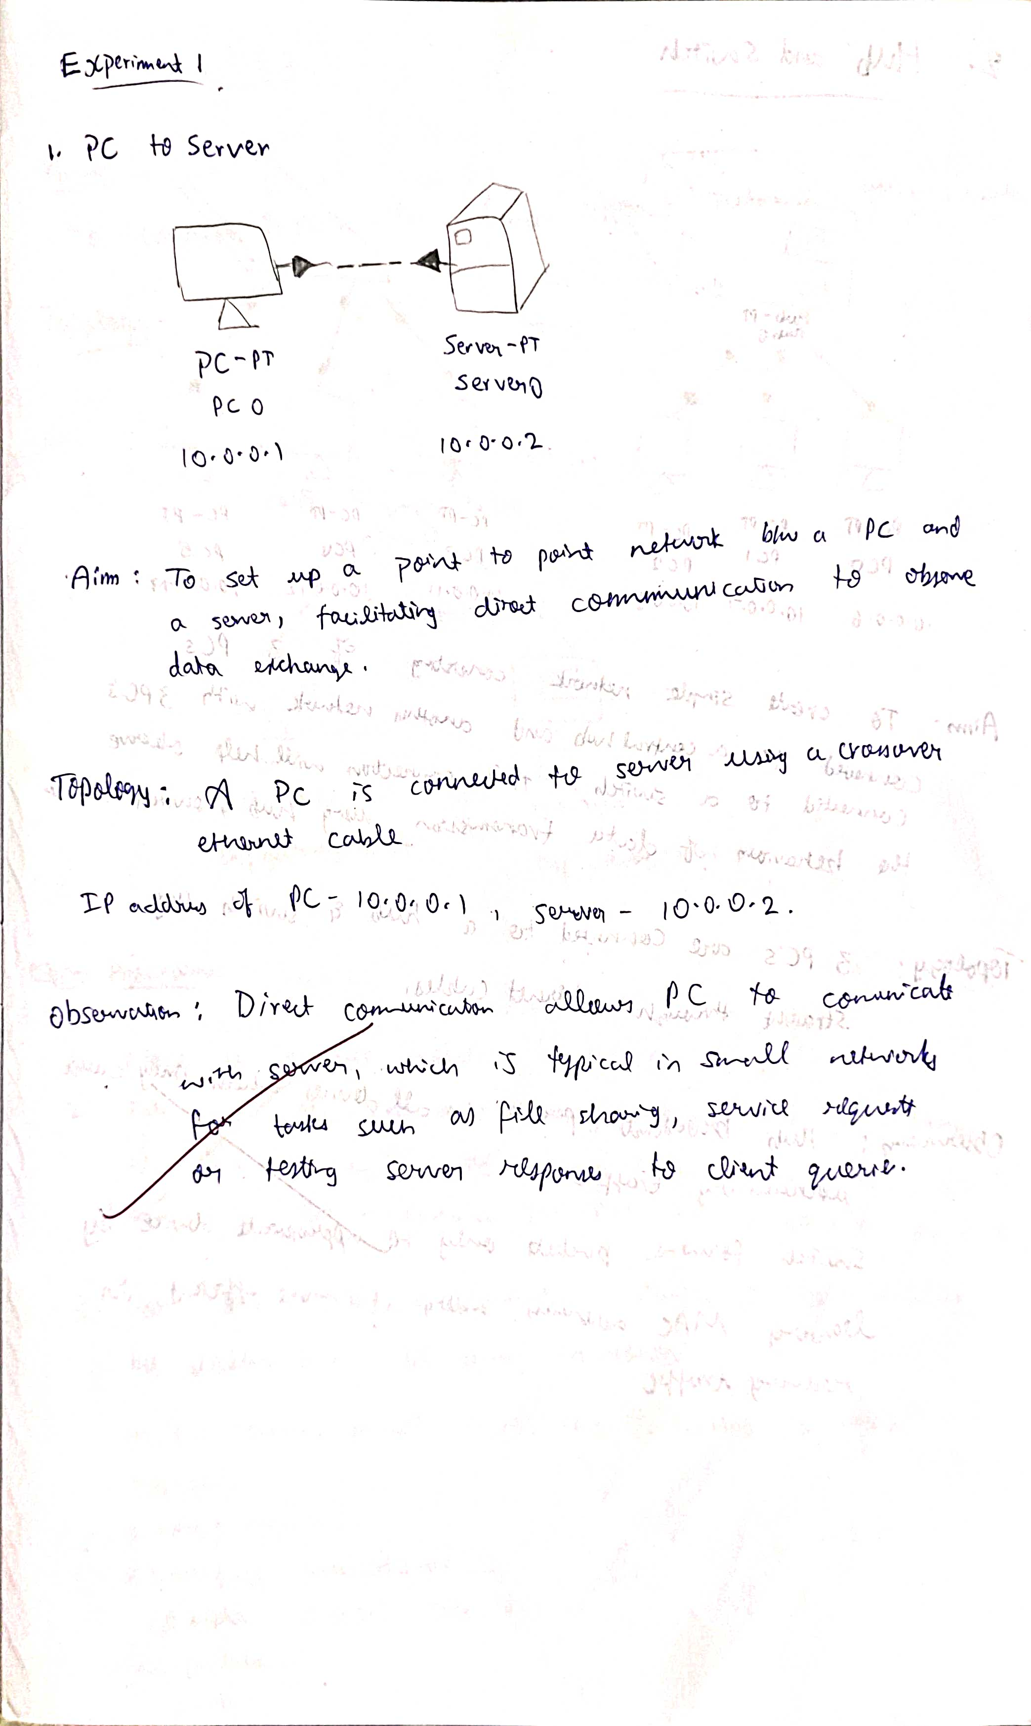

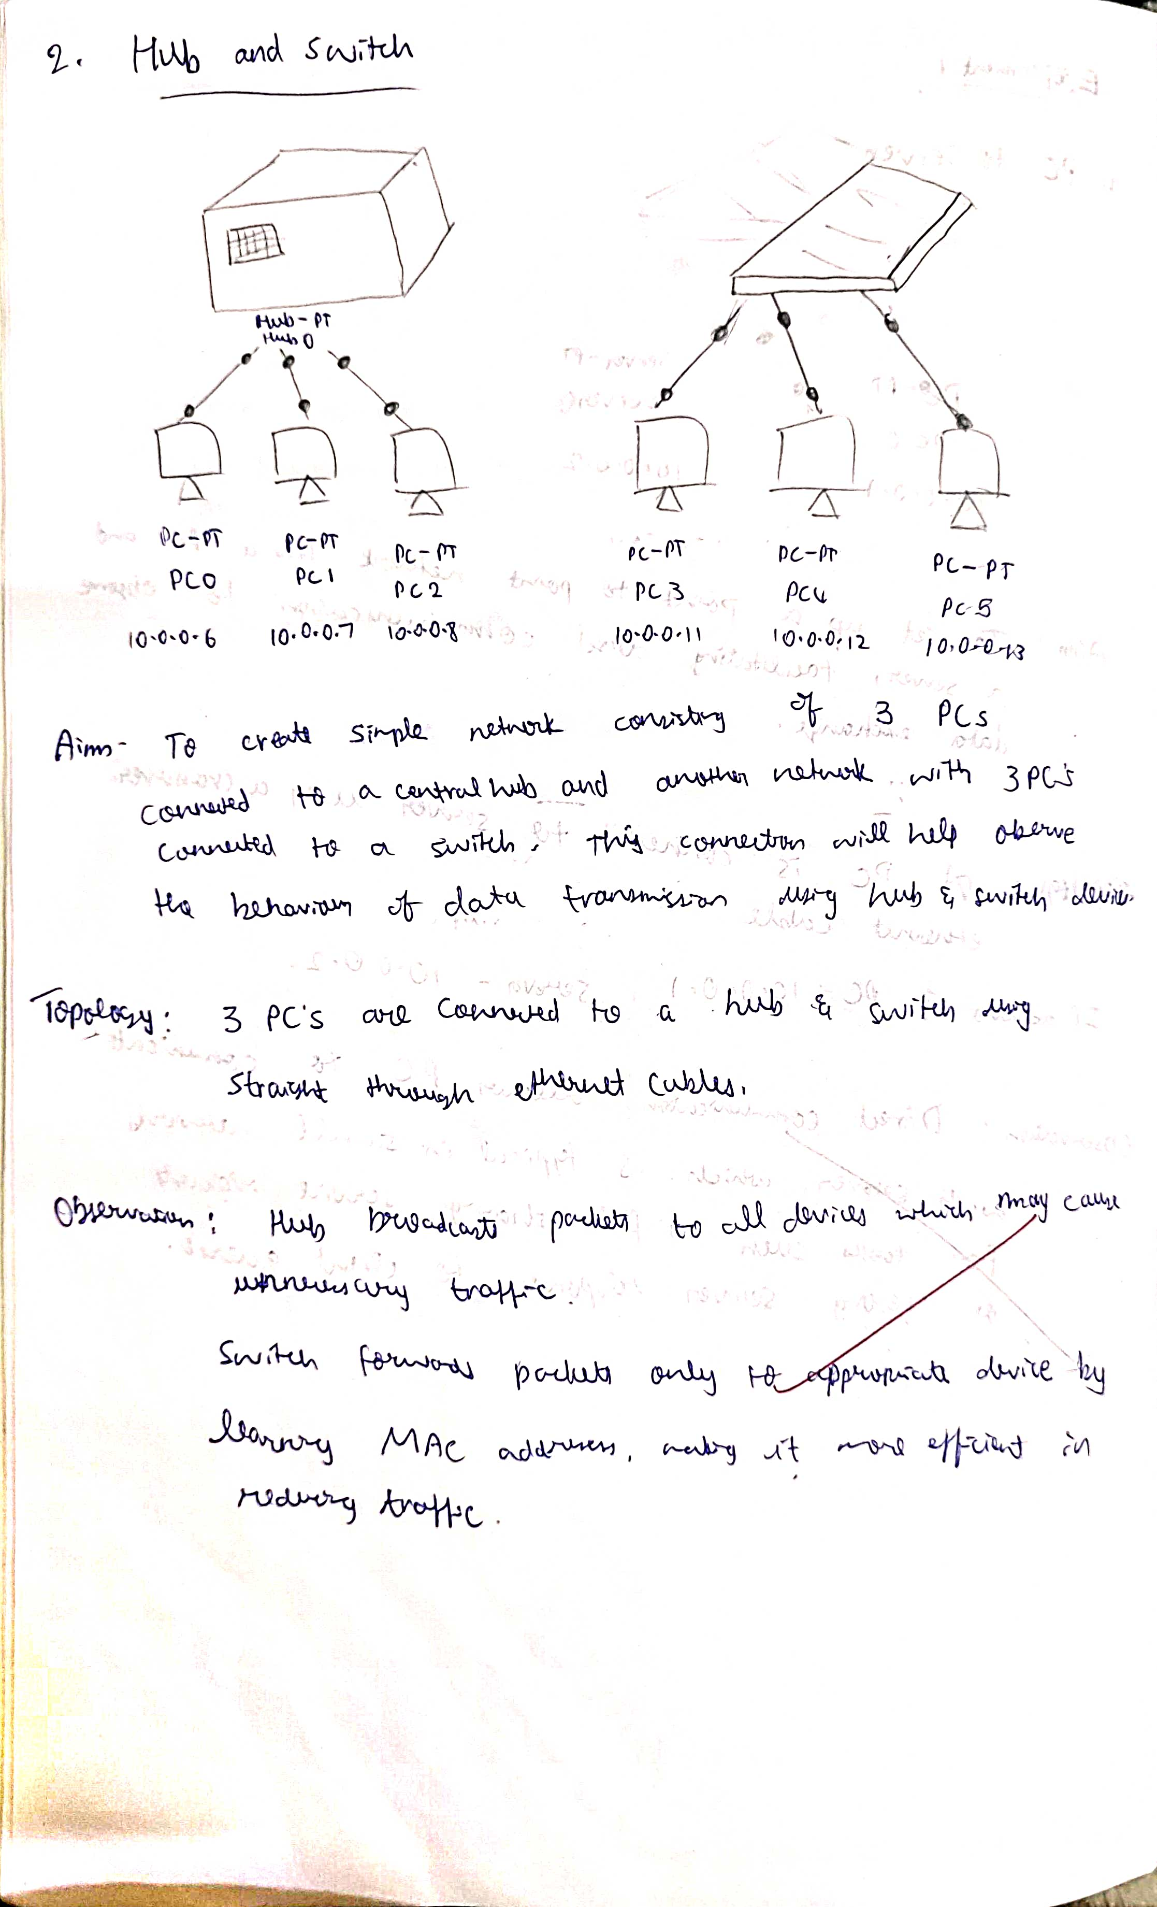

**Screen Shots:**

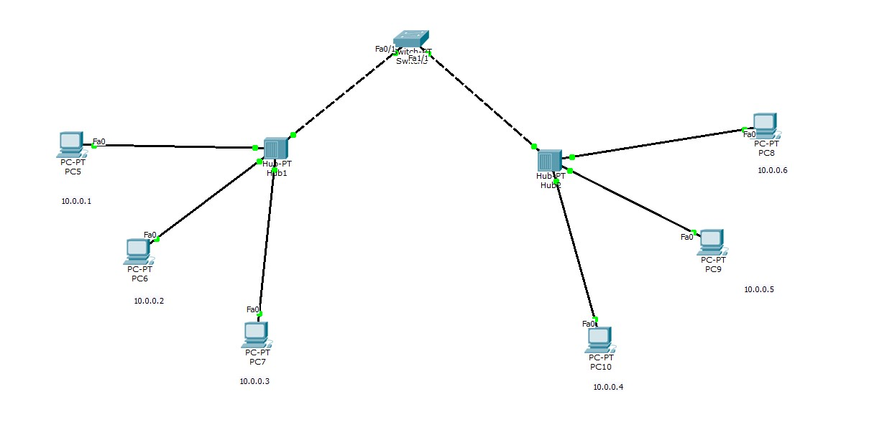

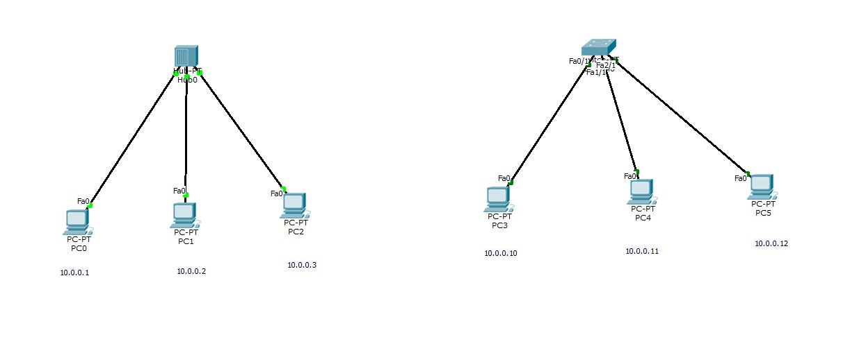

#### Program 2

**Aim:**Configure IP address to routers in packet tracer. Explore the following messages: ping responses, destination unreachable, request timed out, reply.

**Topology , Procedure and Observation:**

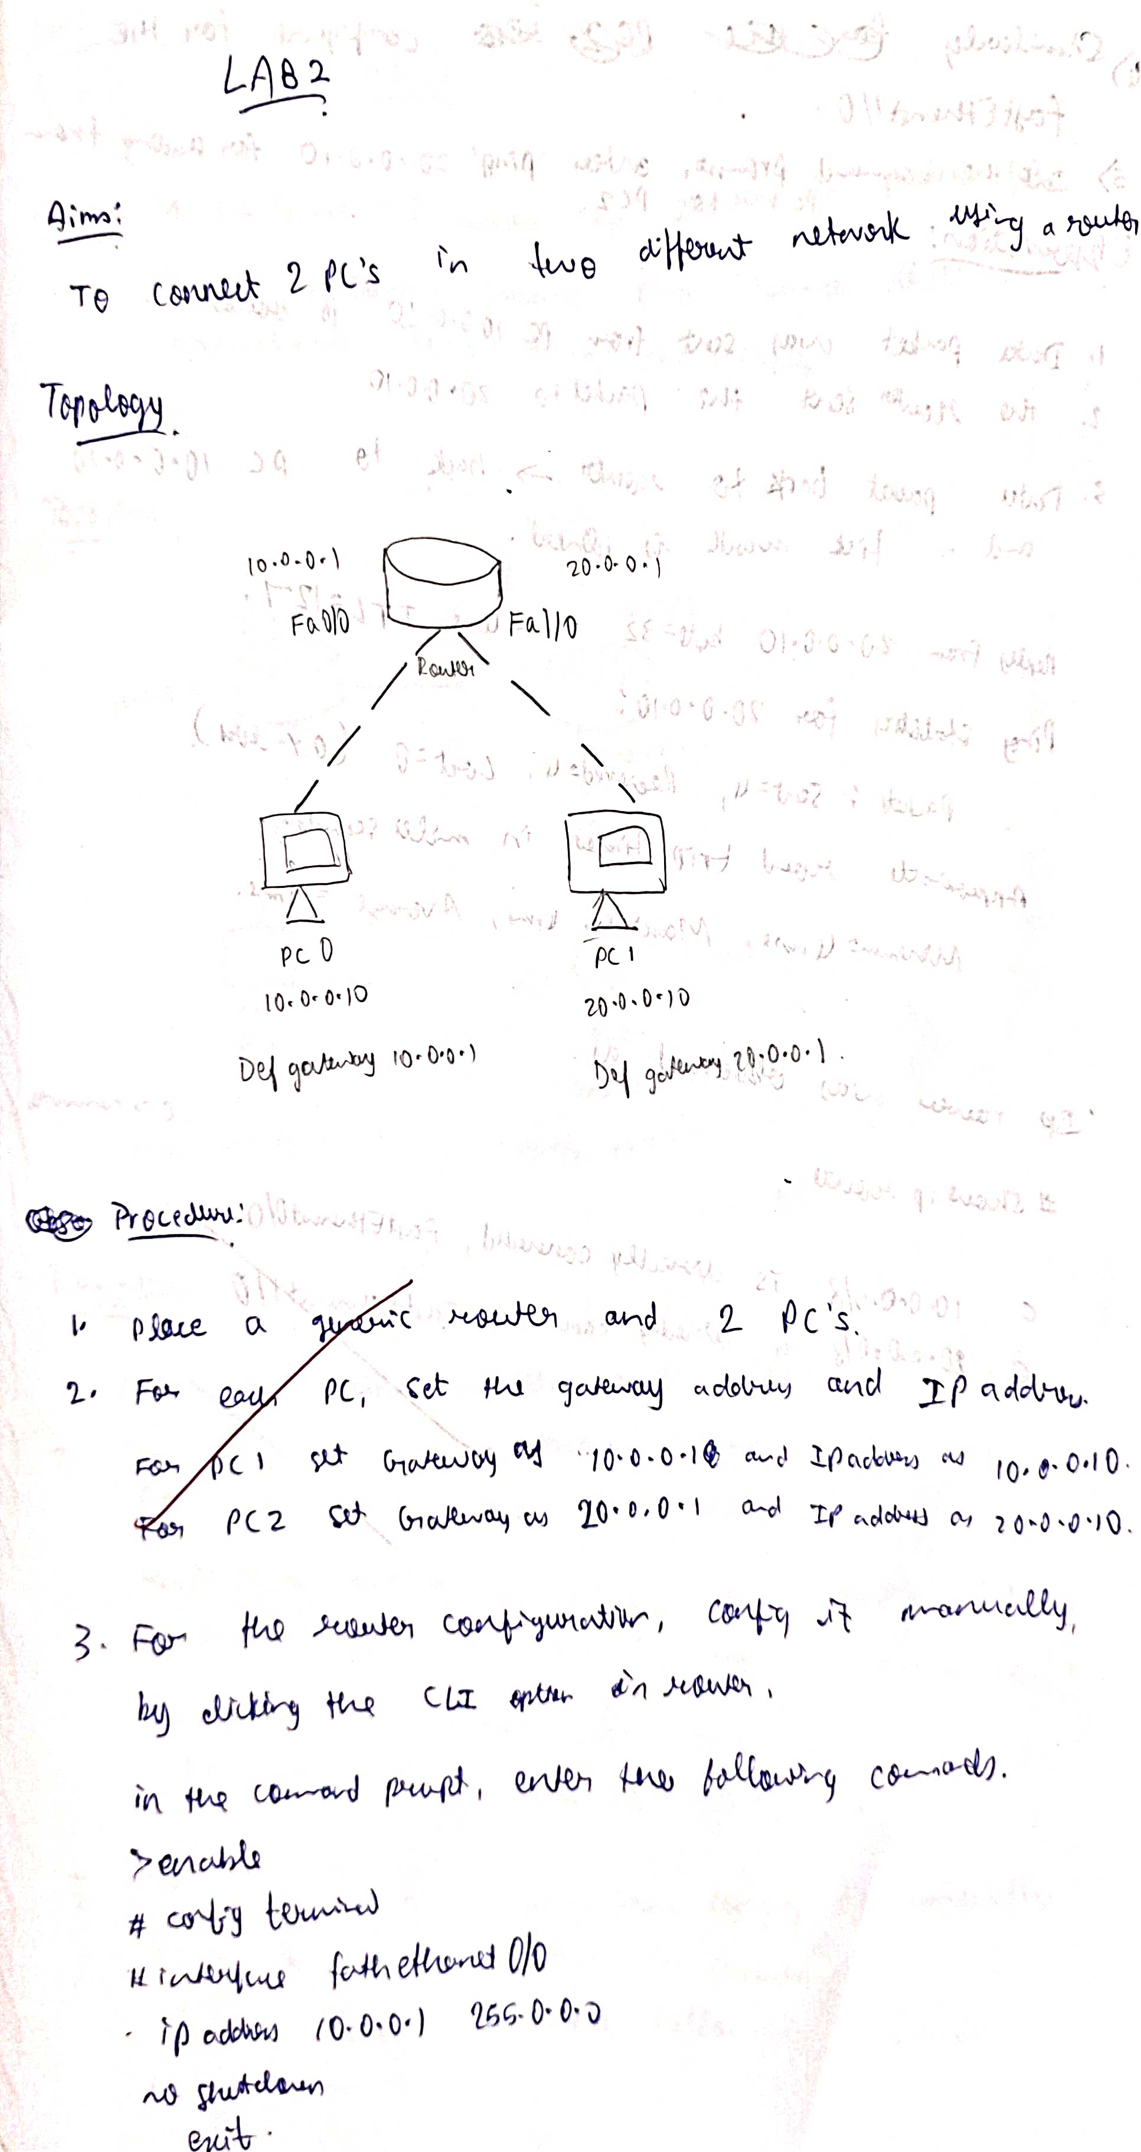

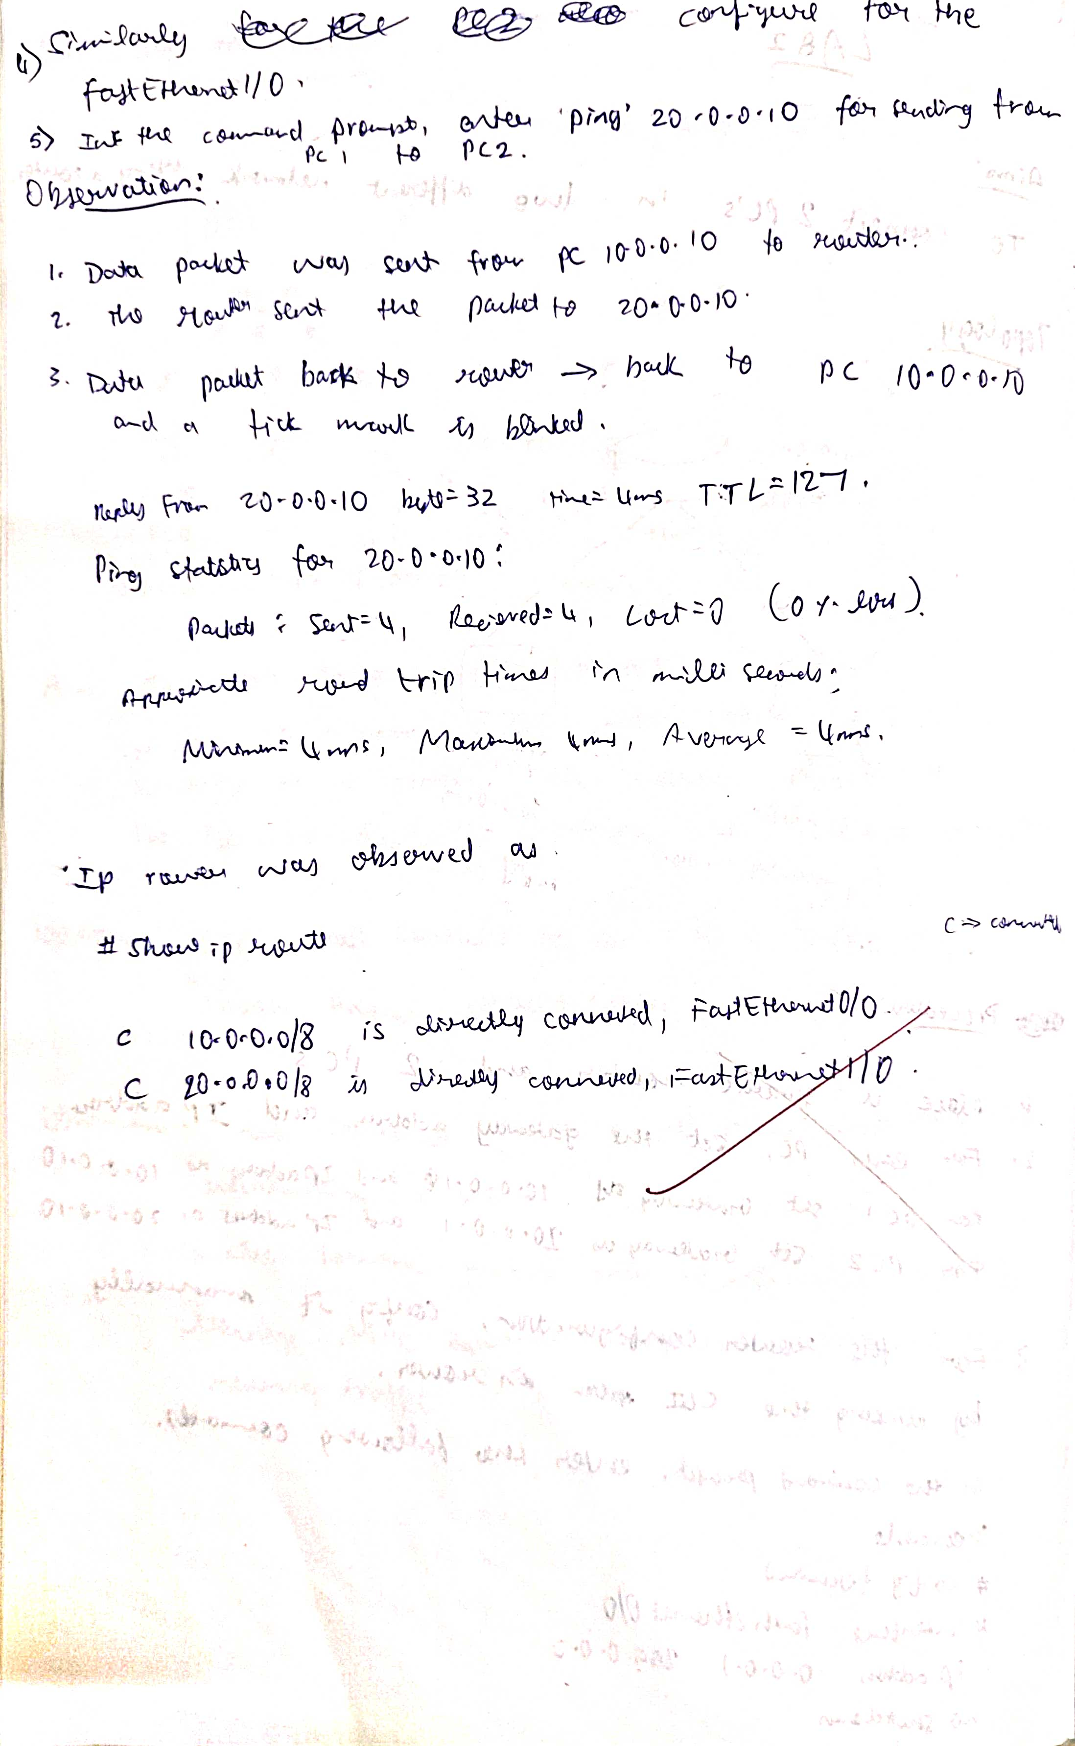

**Screen Shots:**

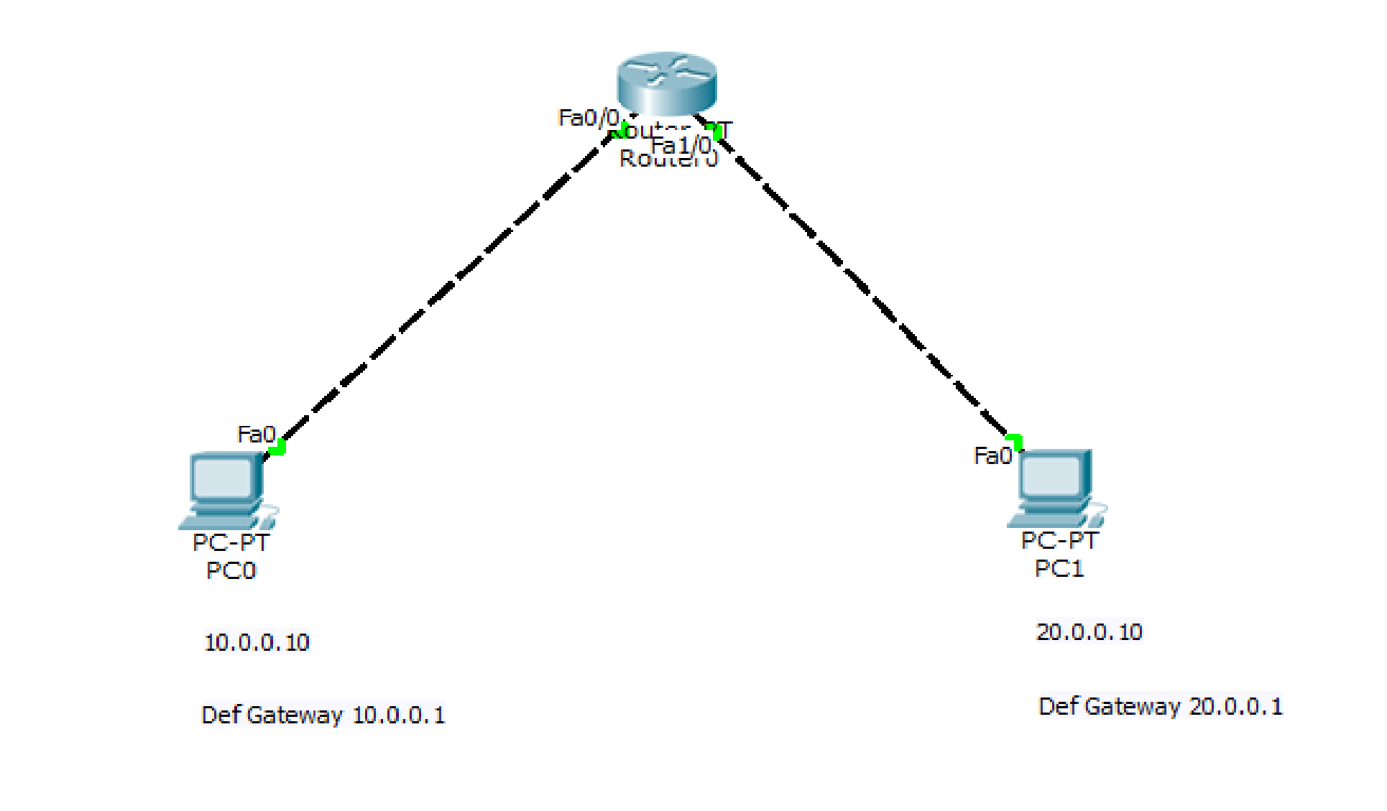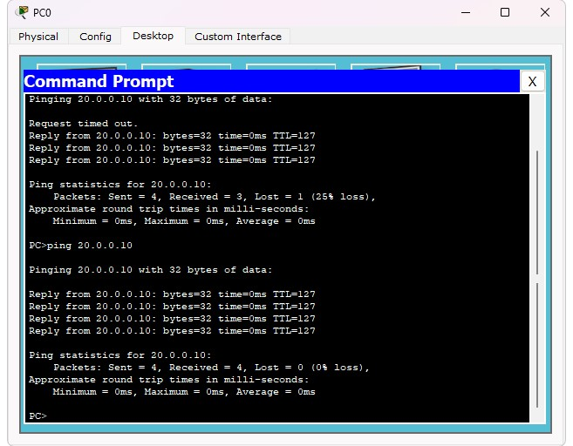

#### Program 3

**Aim:**Configure default route, static route to the Router(Part 1).

**Topology , Procedure and Observation:**

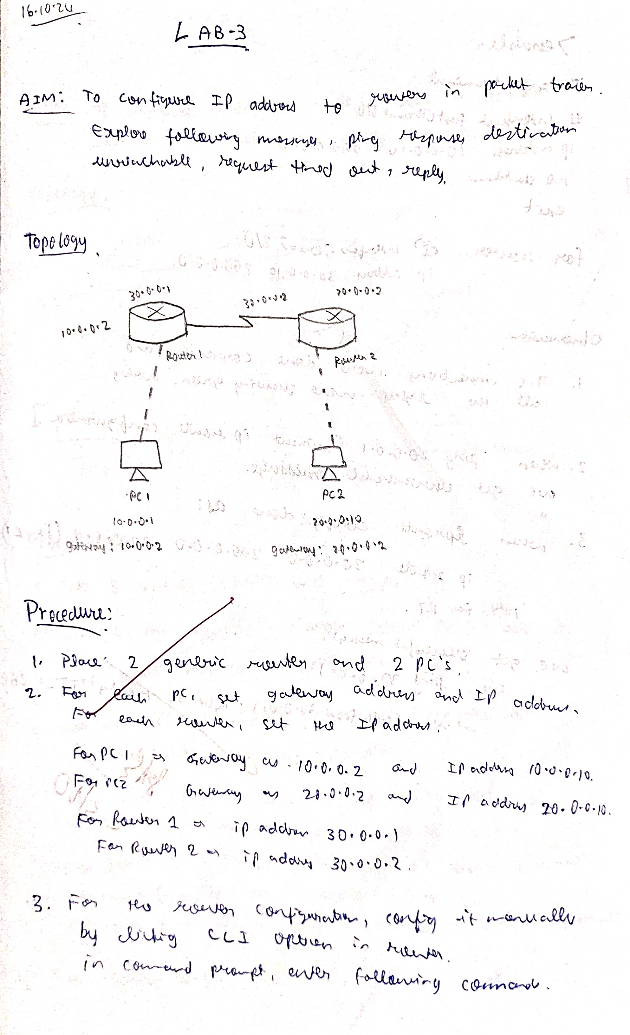

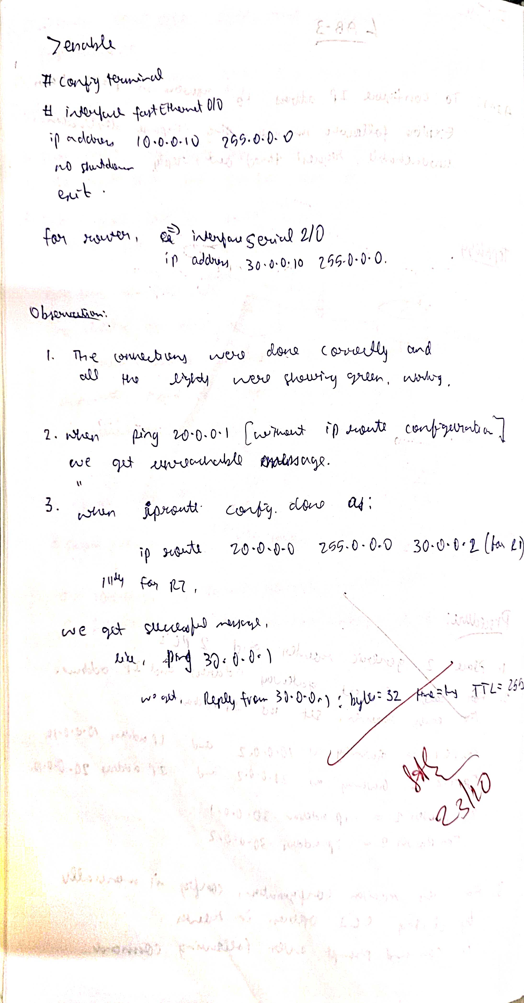

**Screen Shots:**

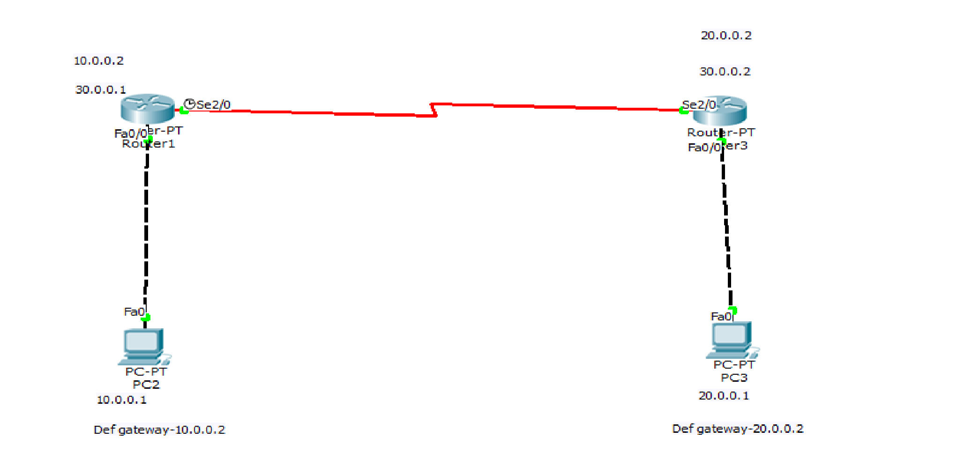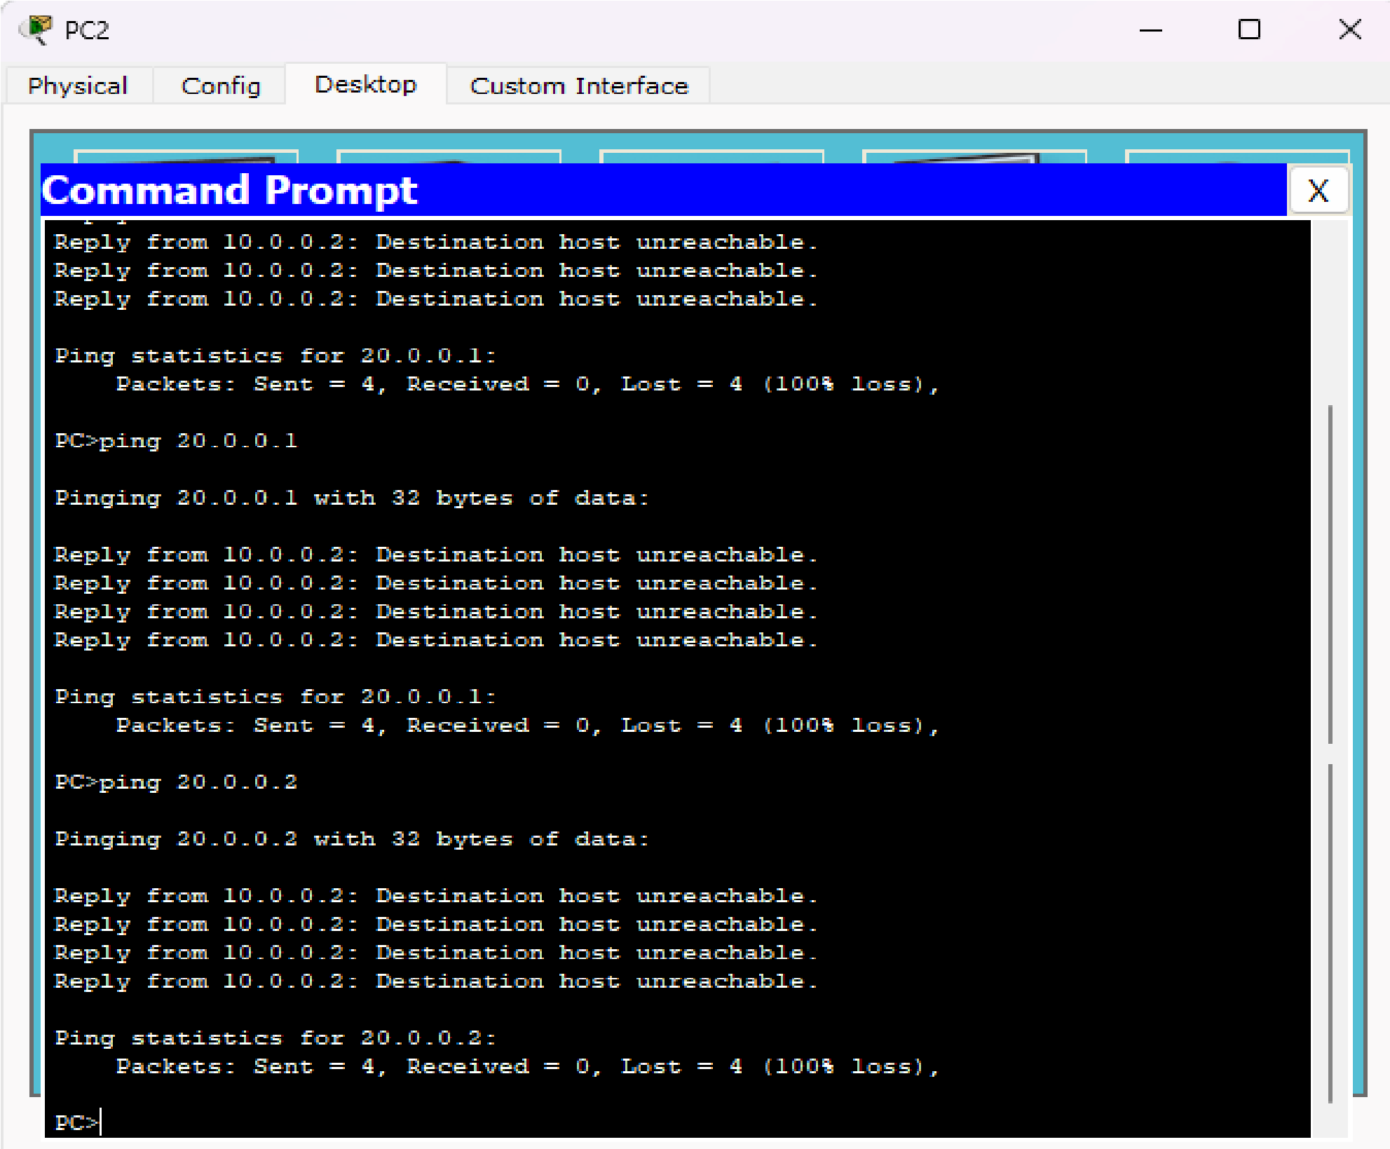

#### Program 4

**Aim:**Configure default route, static route to the Router(Part 2).

**Topology , Procedure and Observation:**

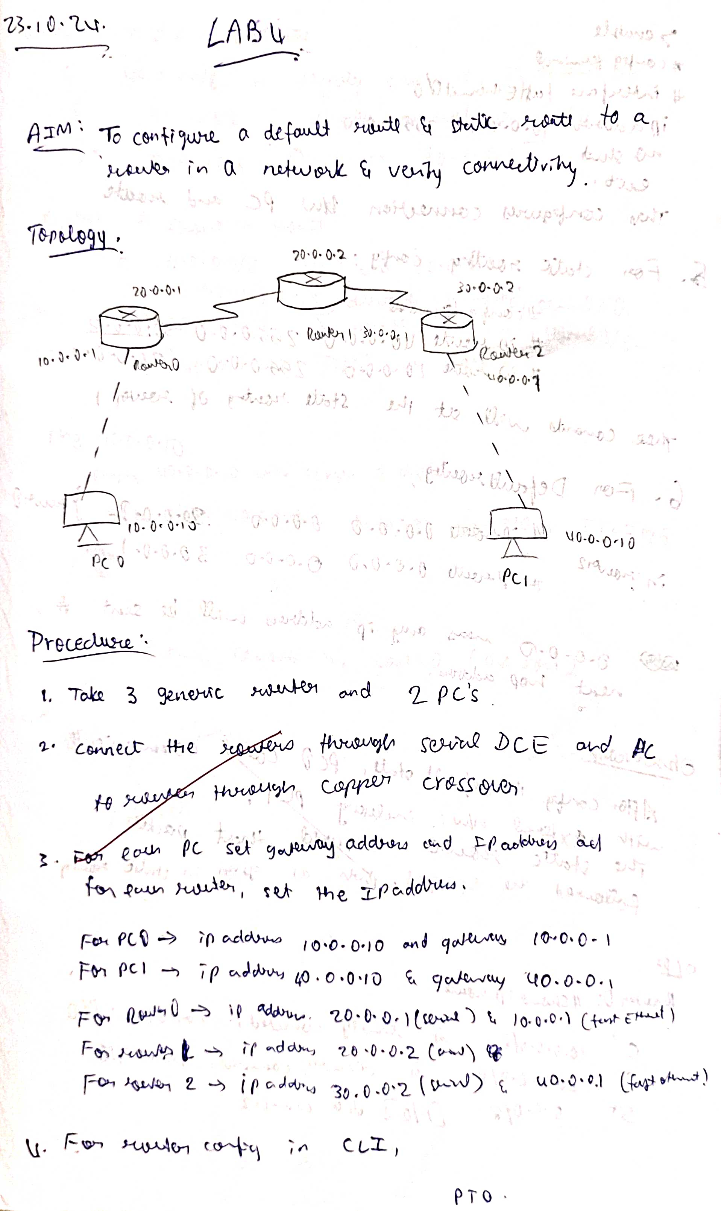

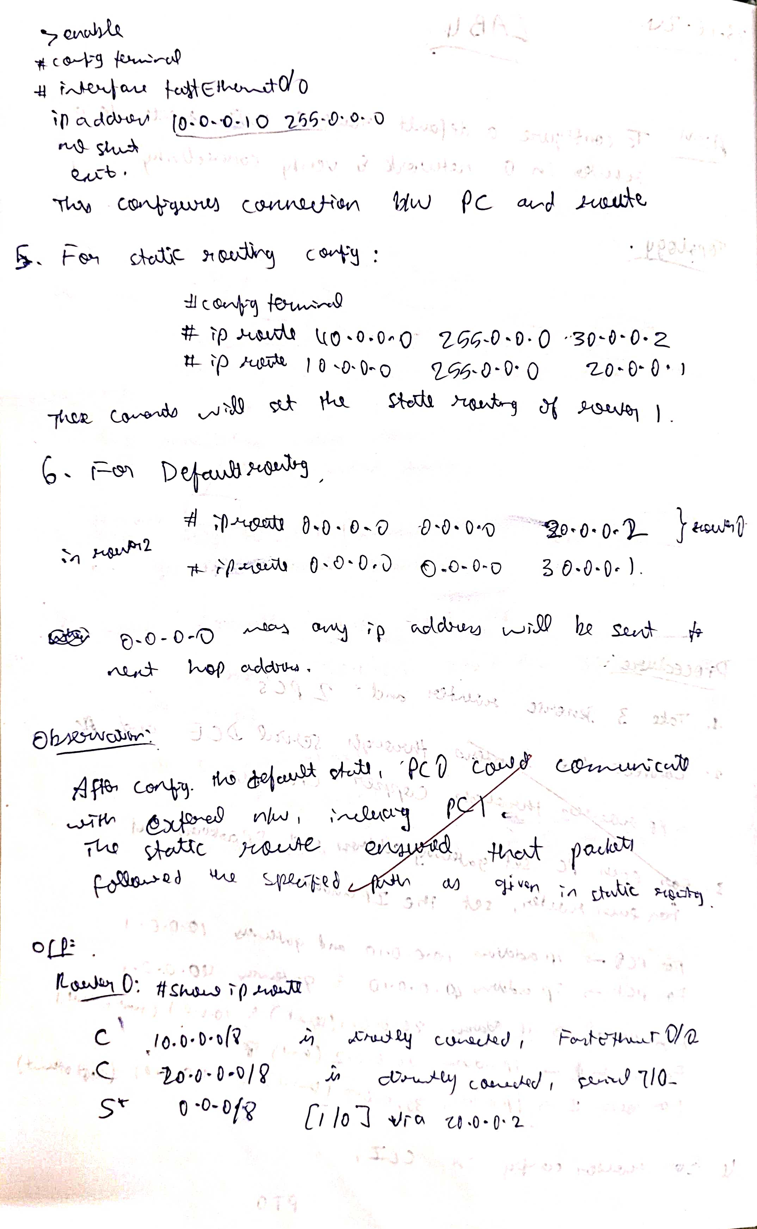

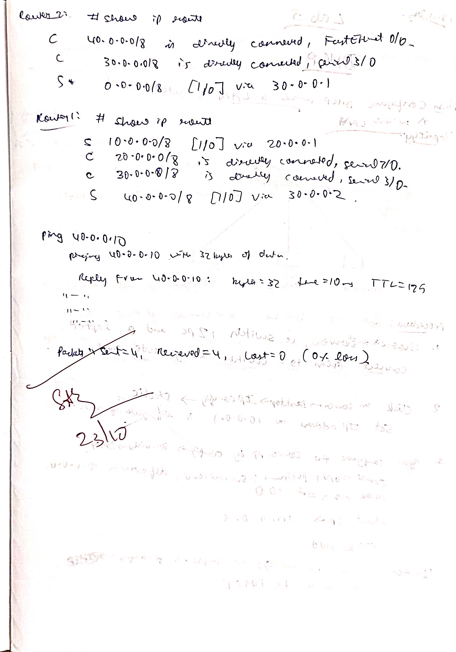

**Screen Shots:**

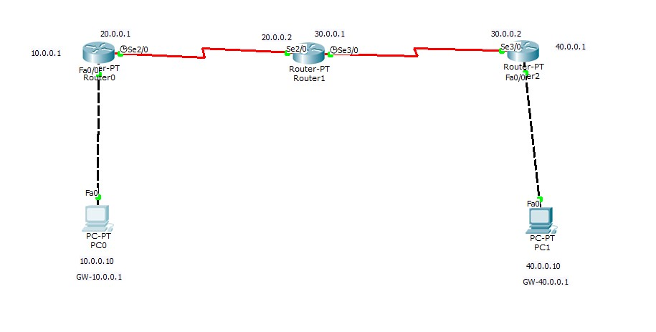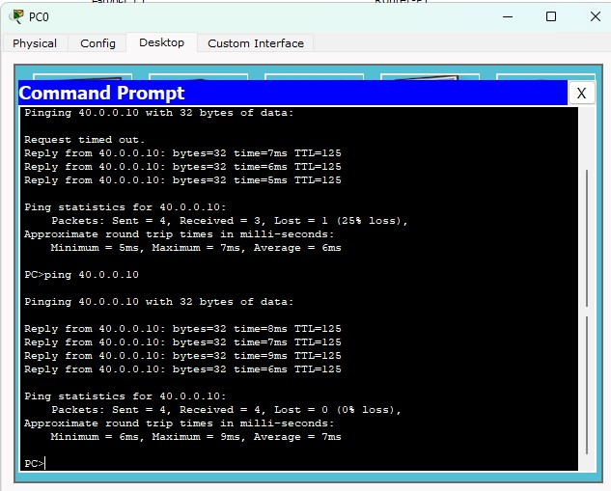

**Program 5**

**Aim:** Configure DHCP within a LAN and outside LAN.

**Topology , Procedure and Observation:**

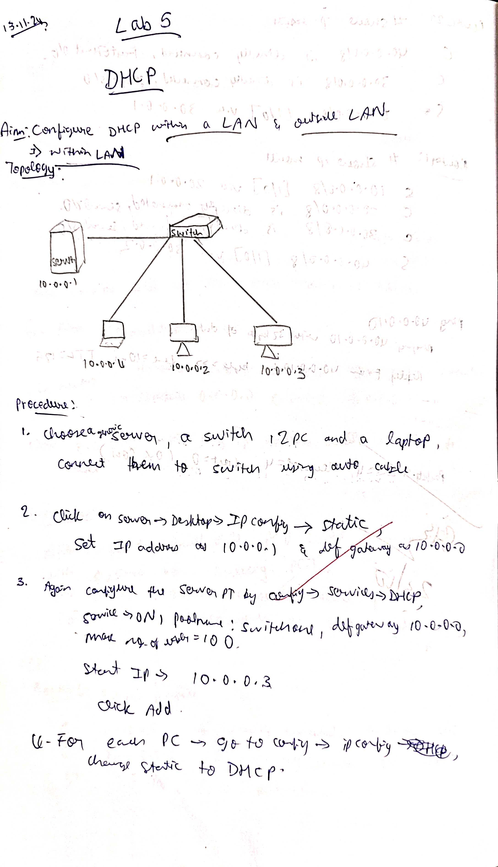

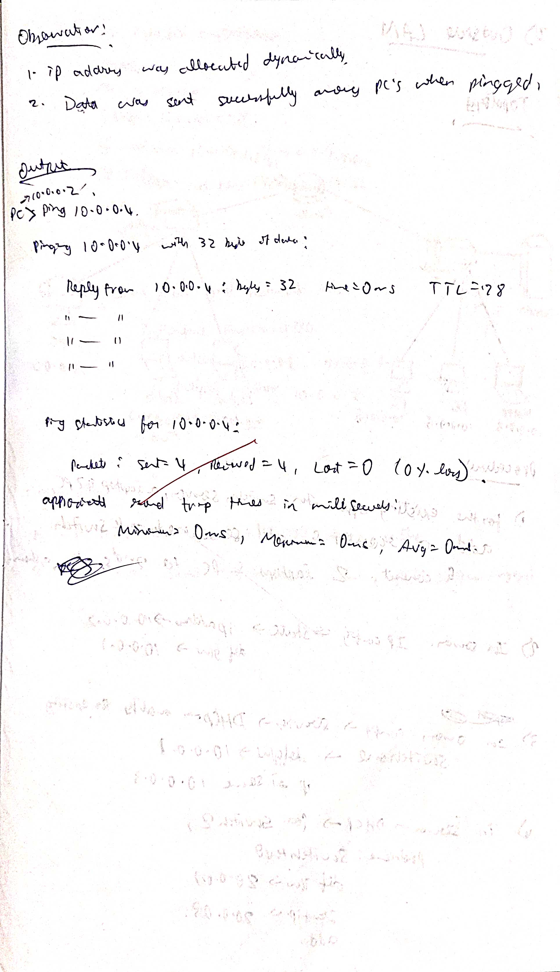

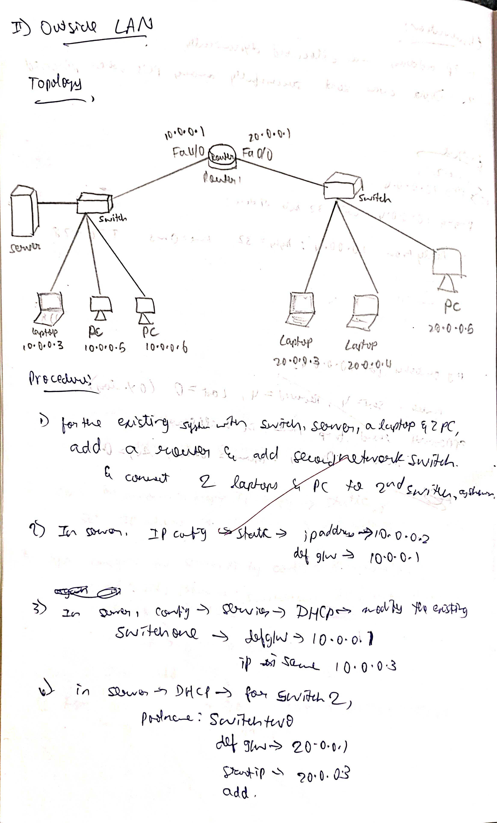

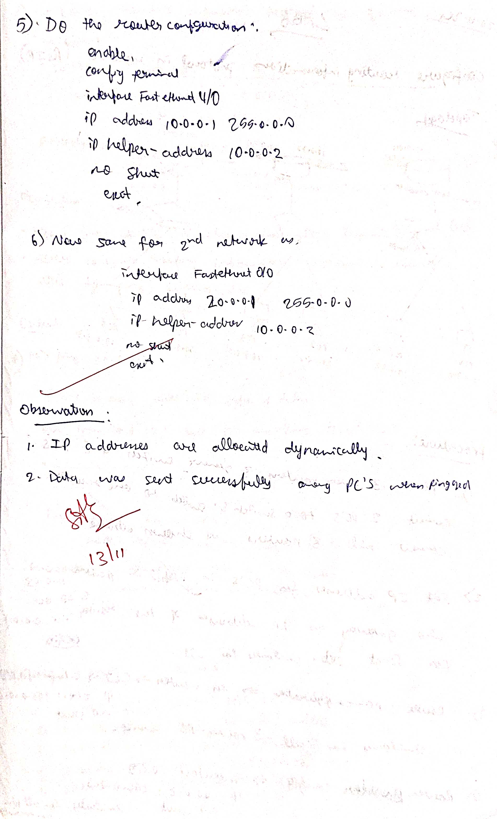

**Screen Shots:**

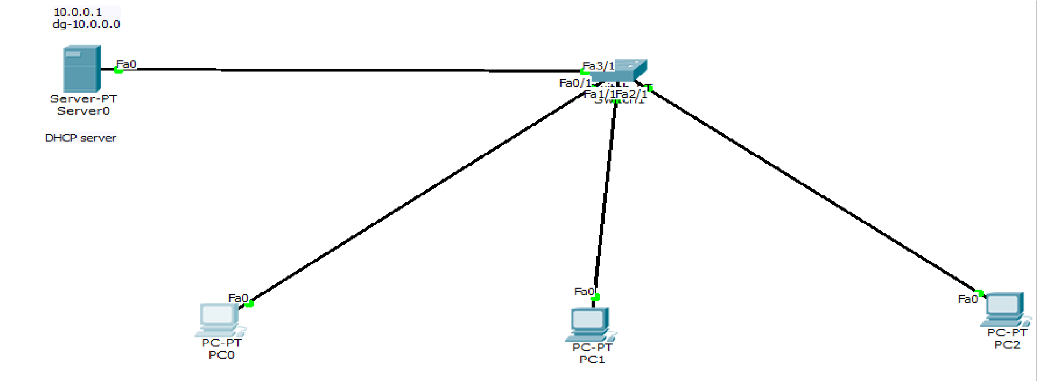

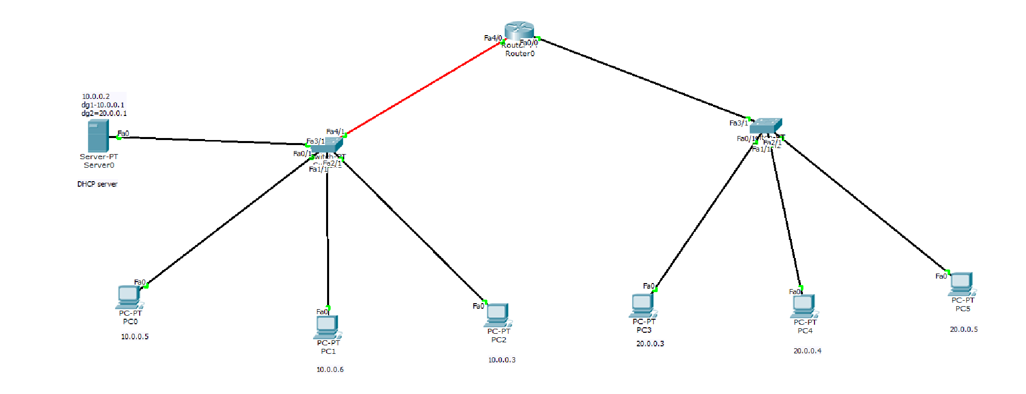

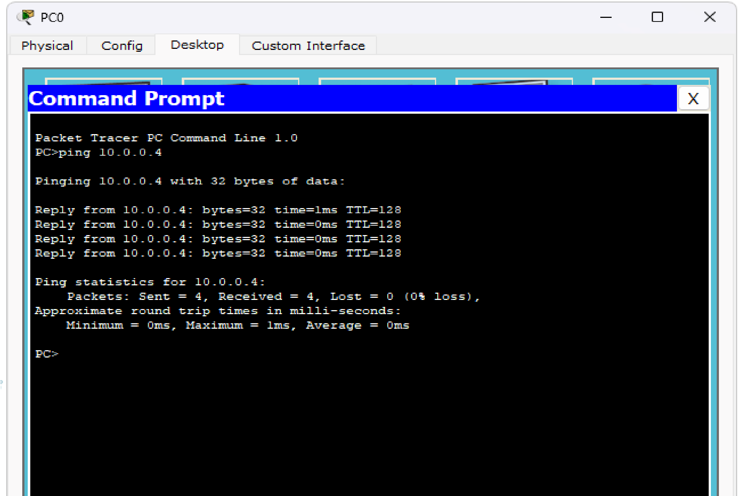

#### Program 6

**Aim:**Configure RIP routing Protocol in Routers .

**Topology , Procedure and Observation:**

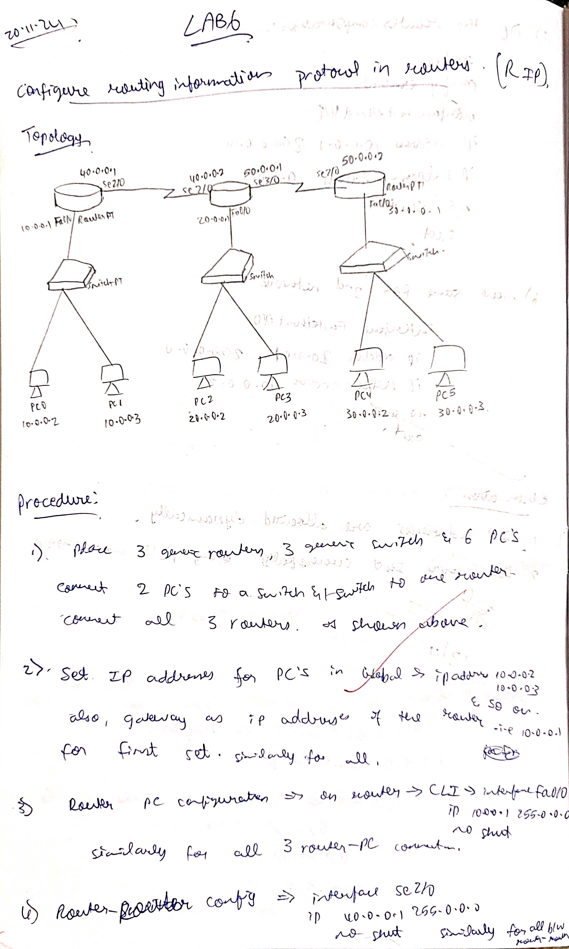

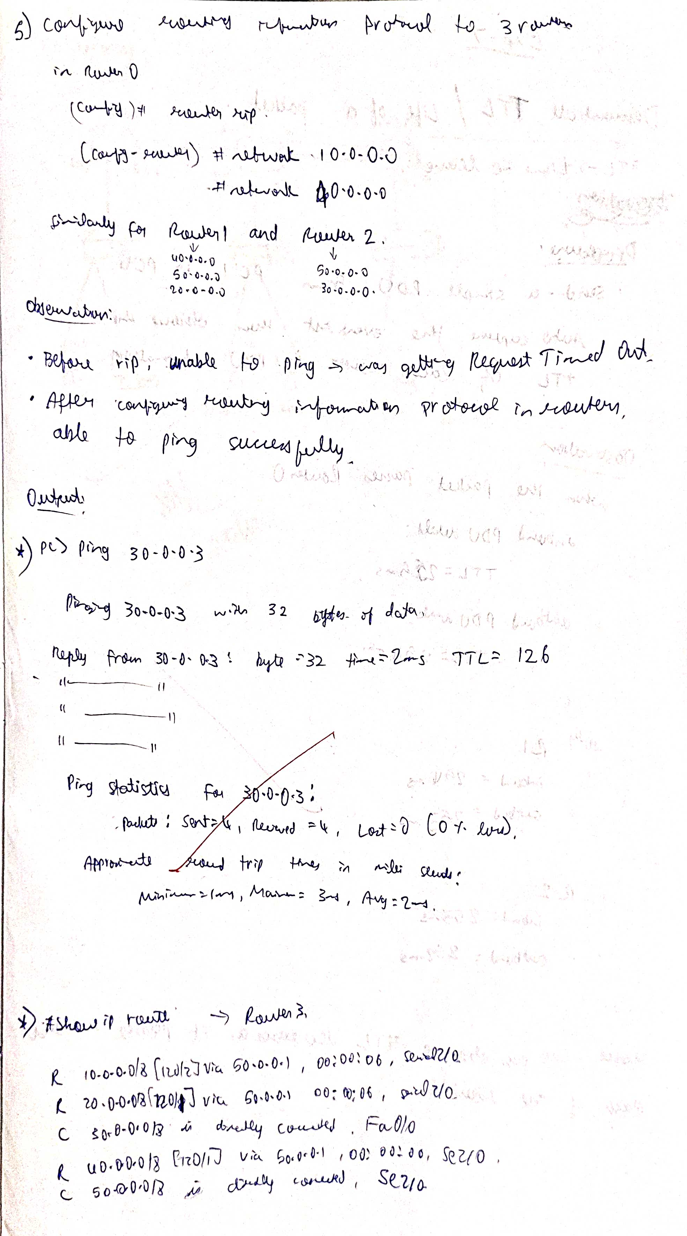

**Screen Shots:**

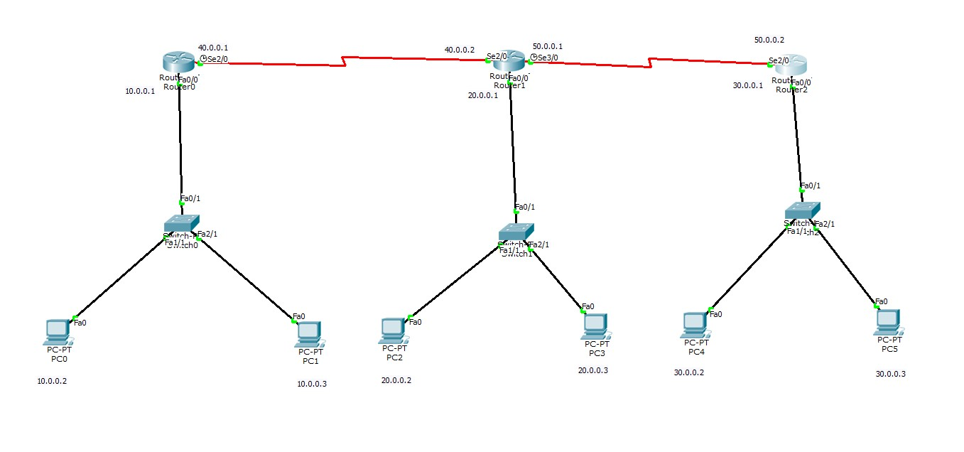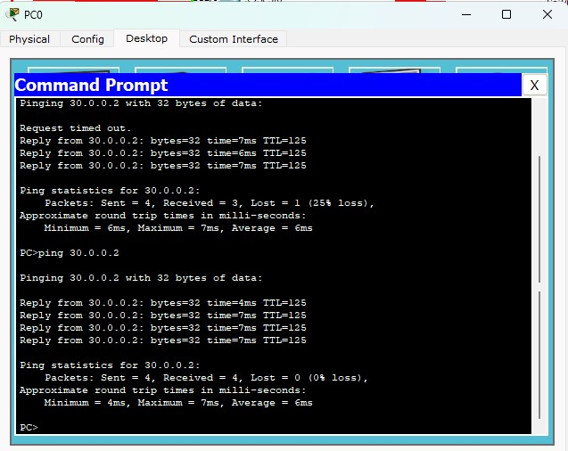

#### Program 7

**Aim:**Demonstrate the TTL/ Life of a Packet .

**Topology , Procedure and Observation:**

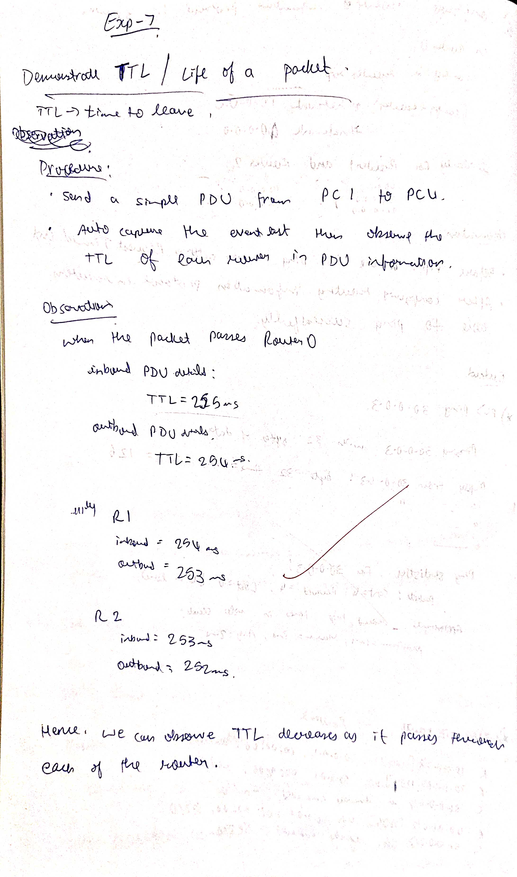

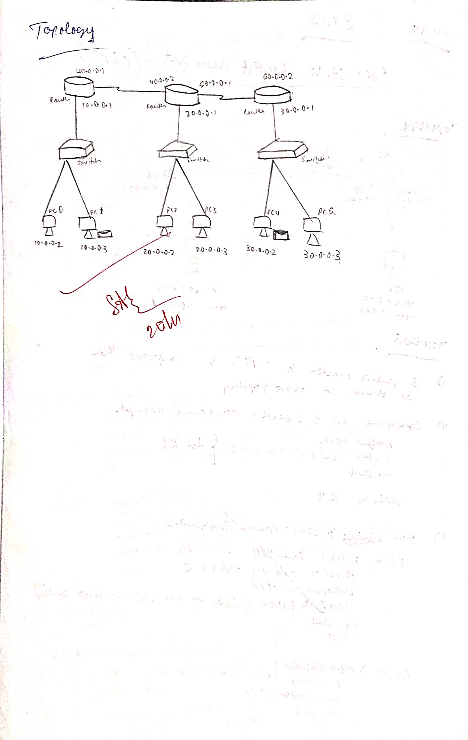

**Screen Shots:**

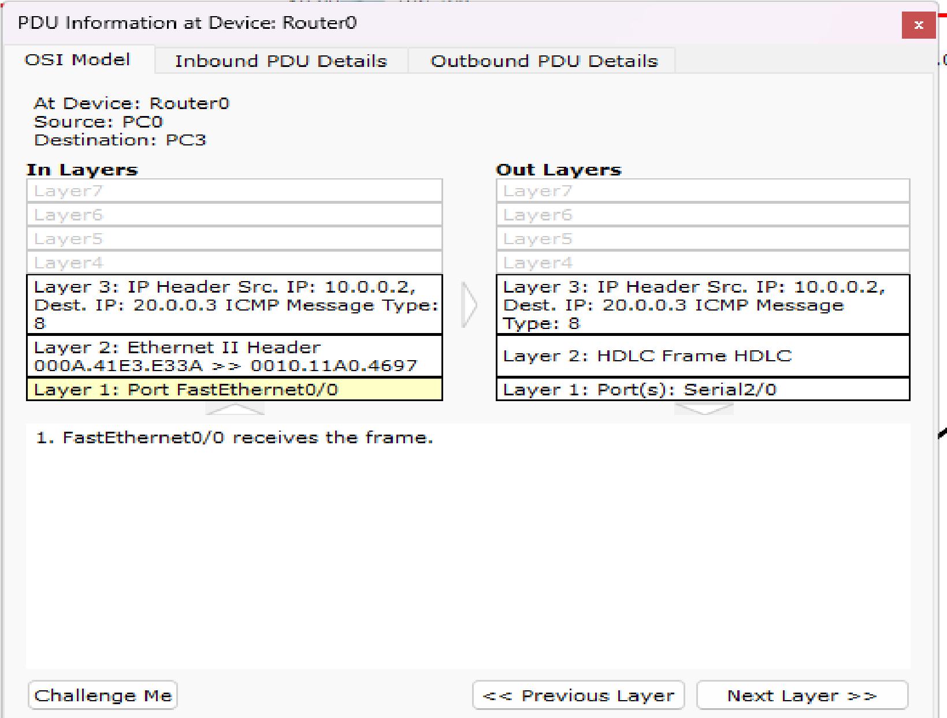

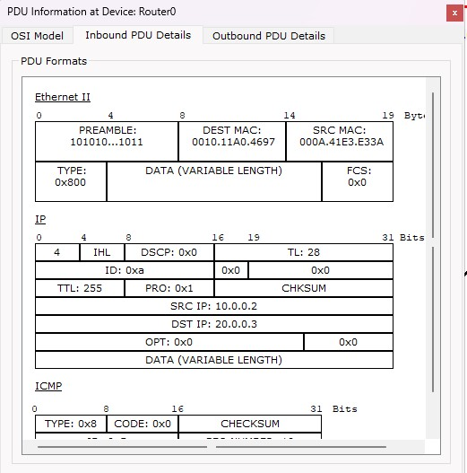

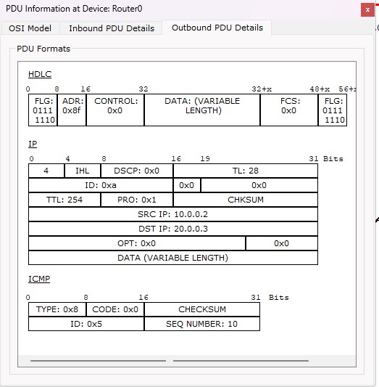

#### Program 8

**Aim:**Configure OSPF routing protocol .

**Topology , Procedure and Observation:**

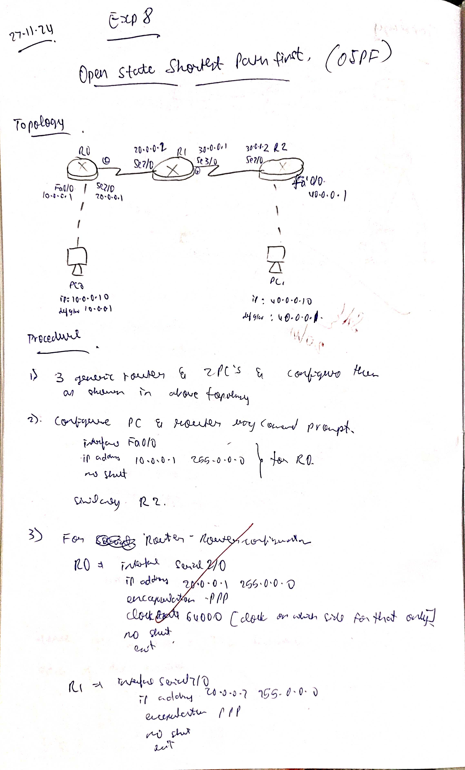

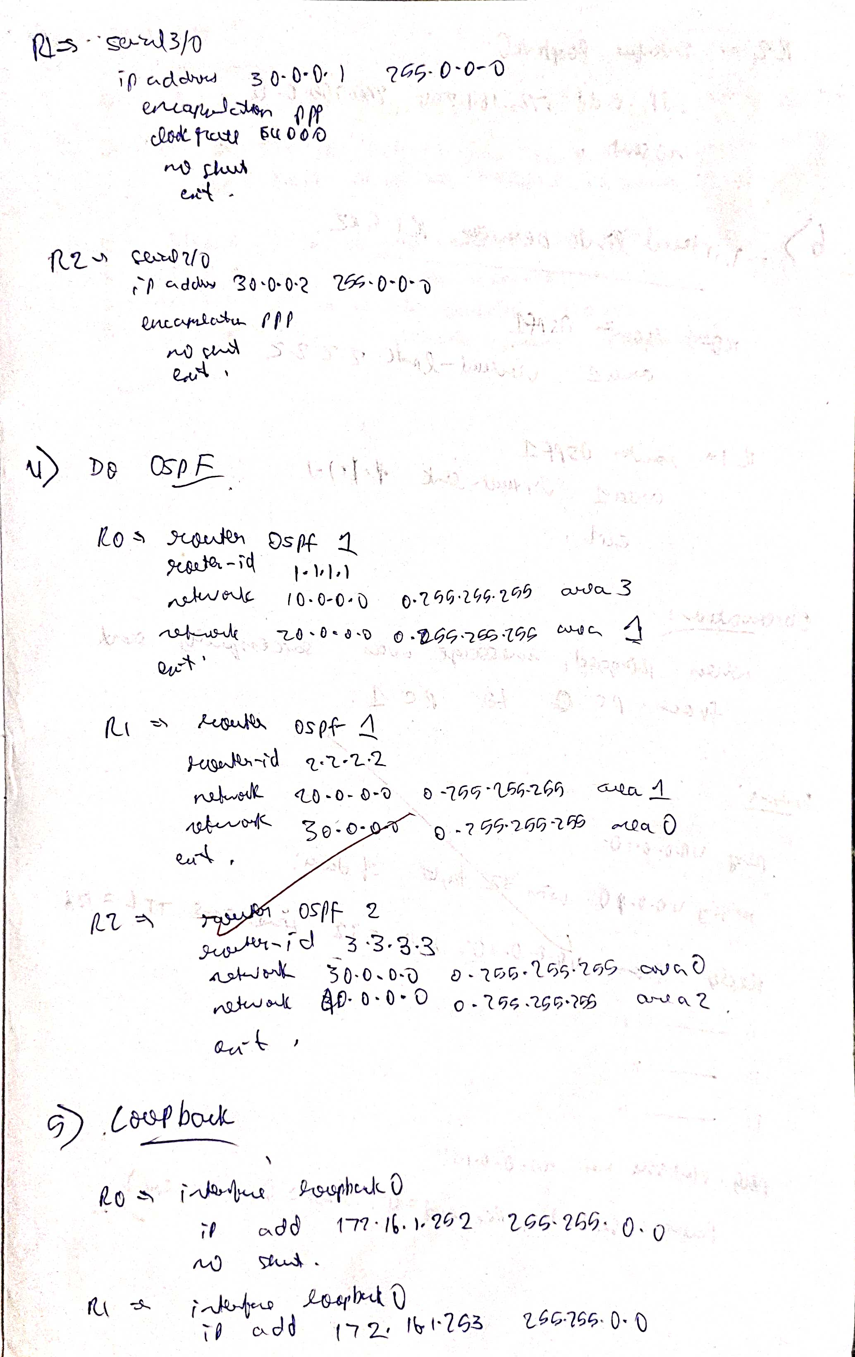

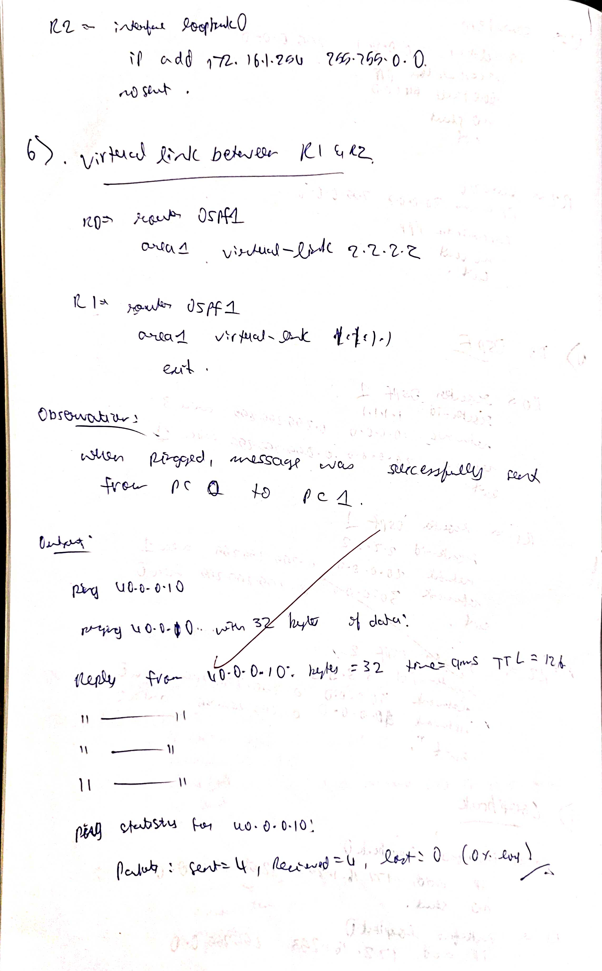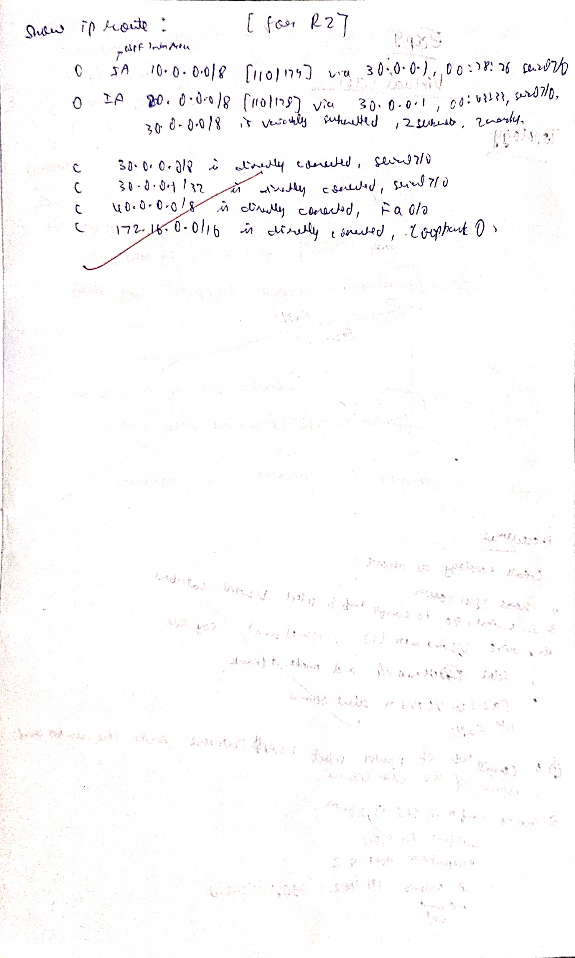

**Screen Shots:**

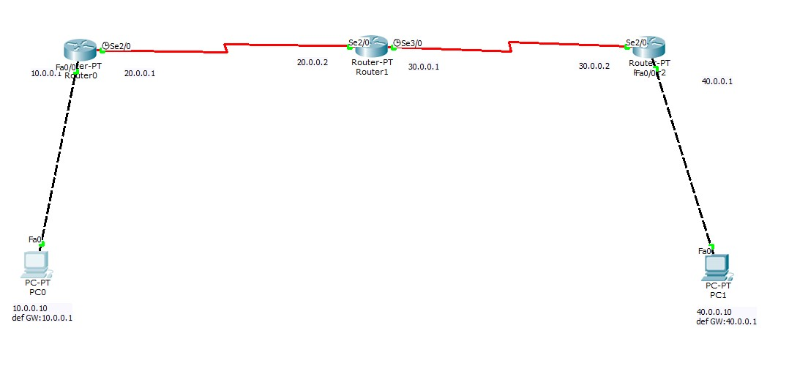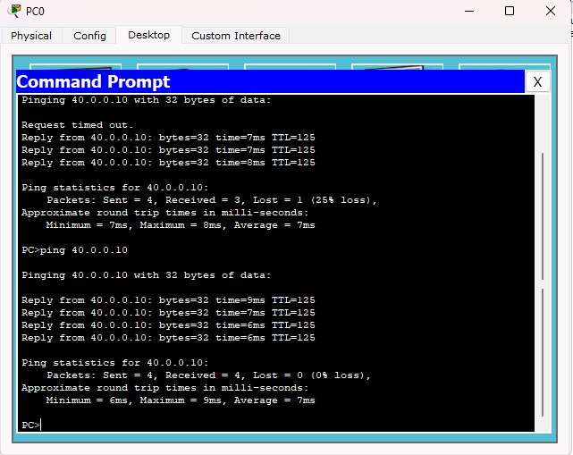

#### Program 9

**Aim:**Configure Web Server, DNS within a LAN.

**Topology , Procedure and Observation:**

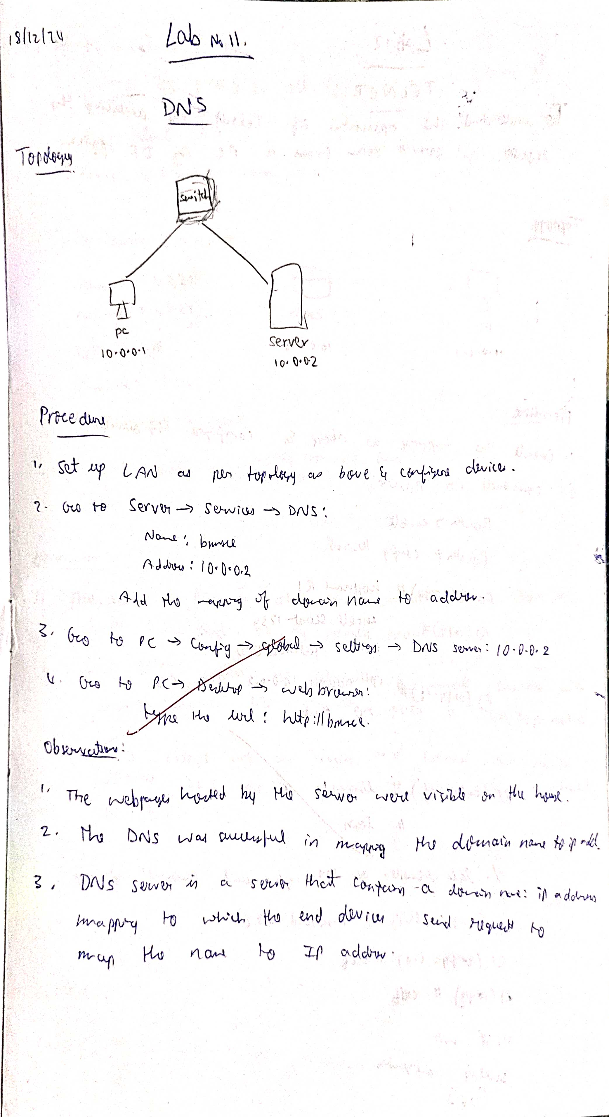

**Screen Shots:**

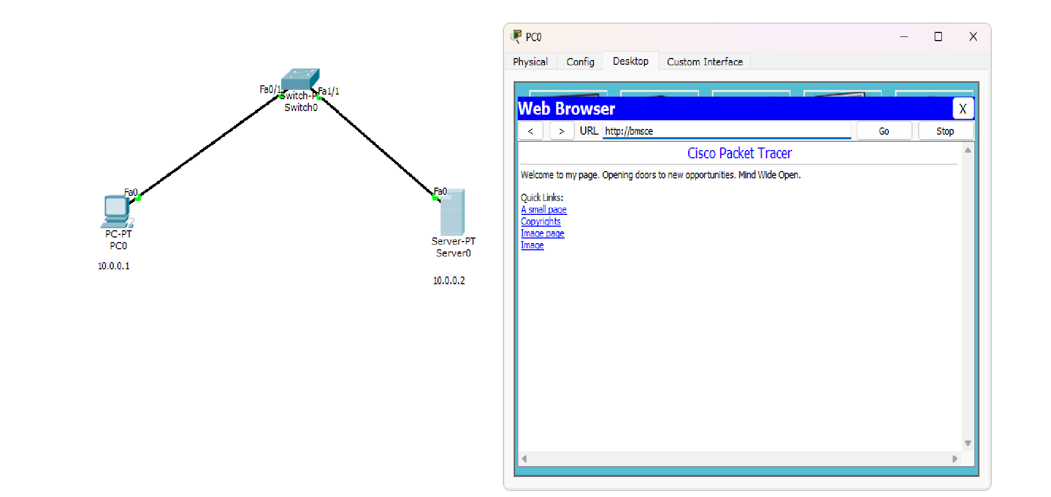

#### Program 10

**Aim:**To construct simple LAN and understand the concept and operation of Address Resolution Protocol (ARP)

**Topology , Procedure and Observation:**

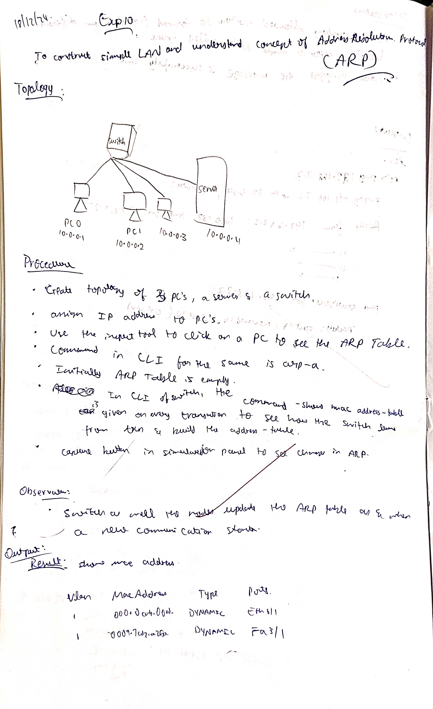

**Screen Shots:**

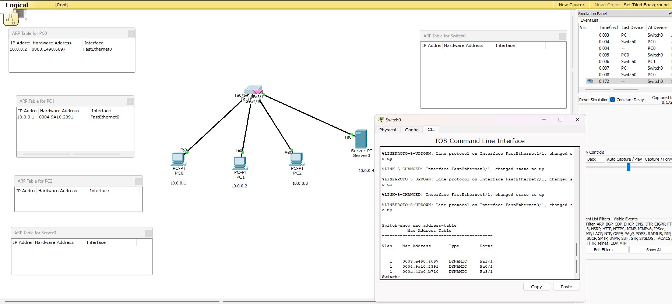

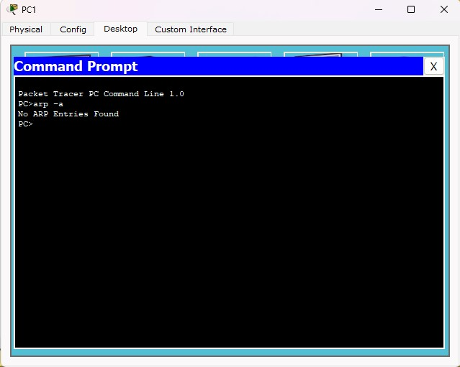

#### Program 11

**Aim:**To understand the operation of TELNET by accessing the router in the server room from a PC in the IT office.

**Topology , Procedure and Observation:**

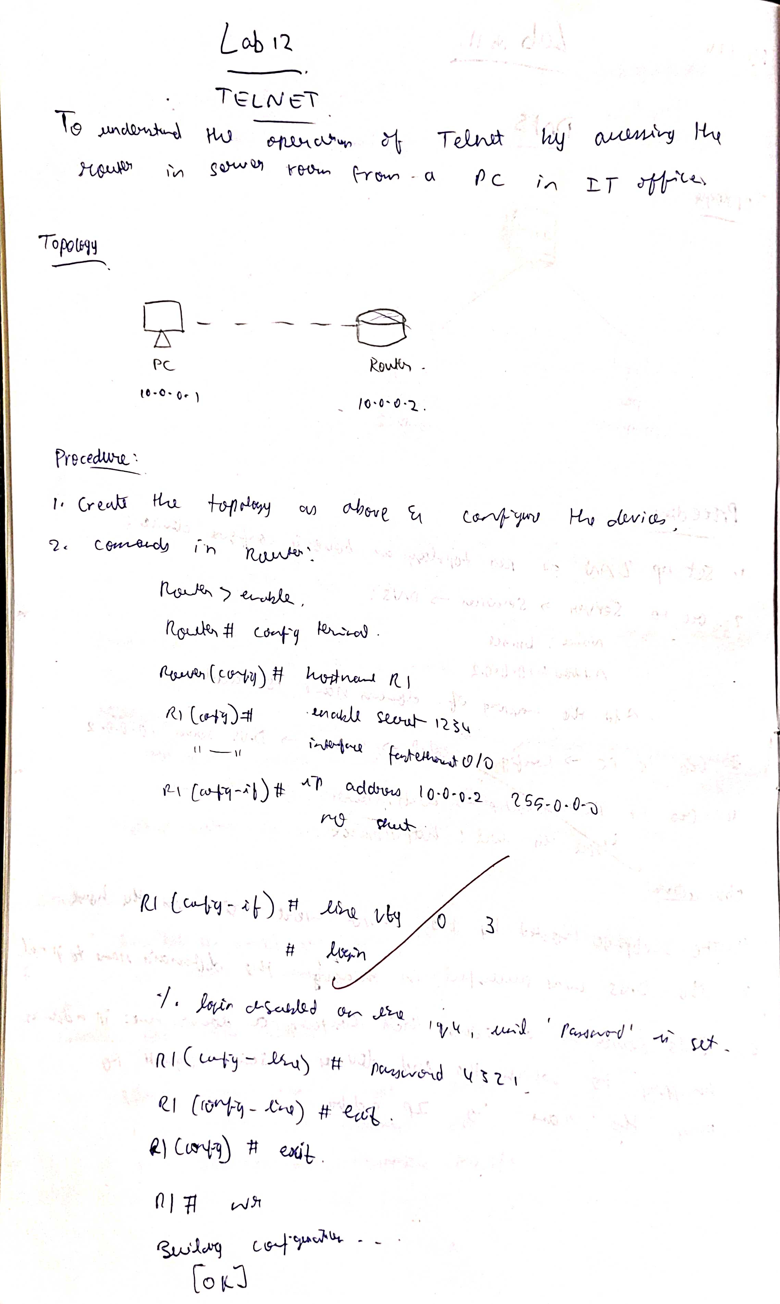

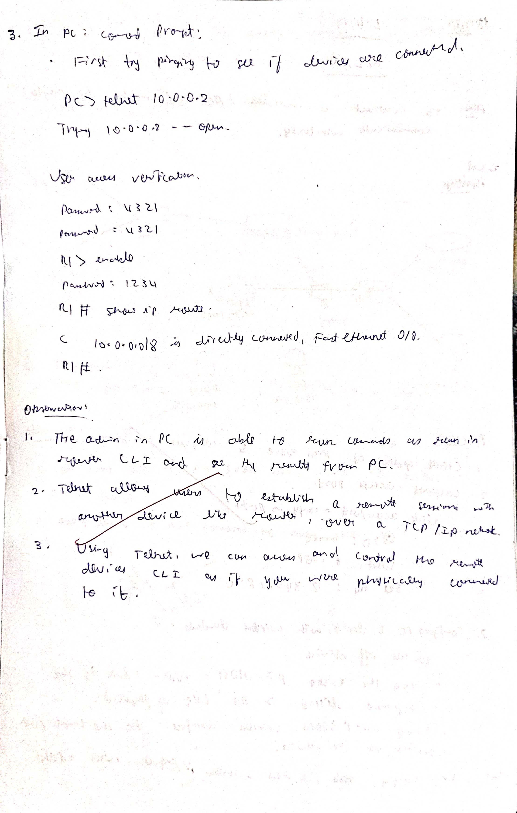

**Screen Shots:**

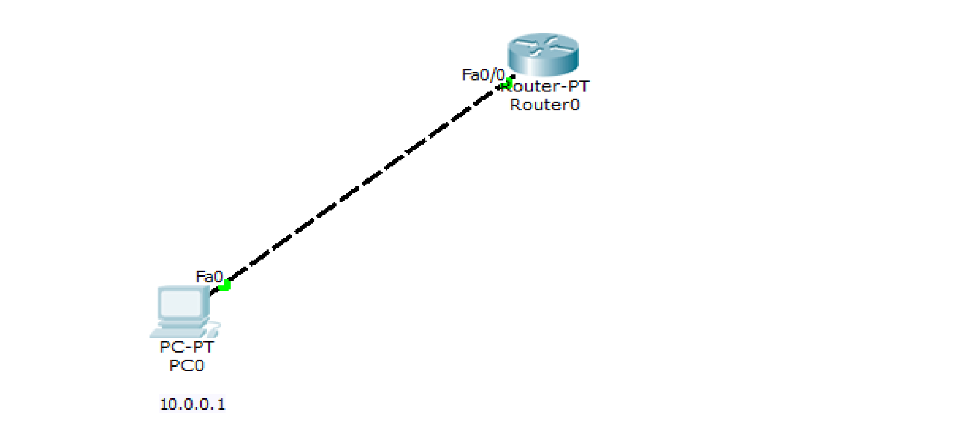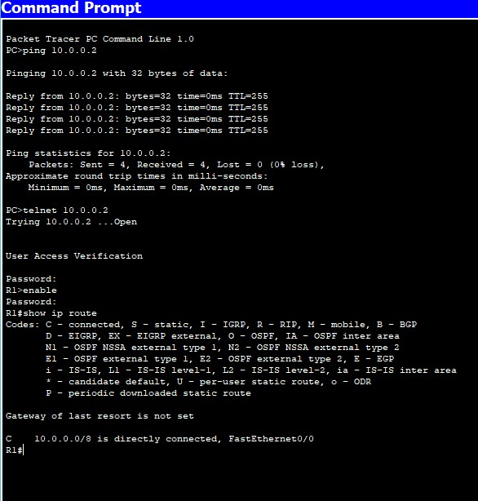

#### Program 12

**Aim:**To construct a VLAN and make the PC’s communicate among a VLAN .

**Topology , Procedure and Observation:**

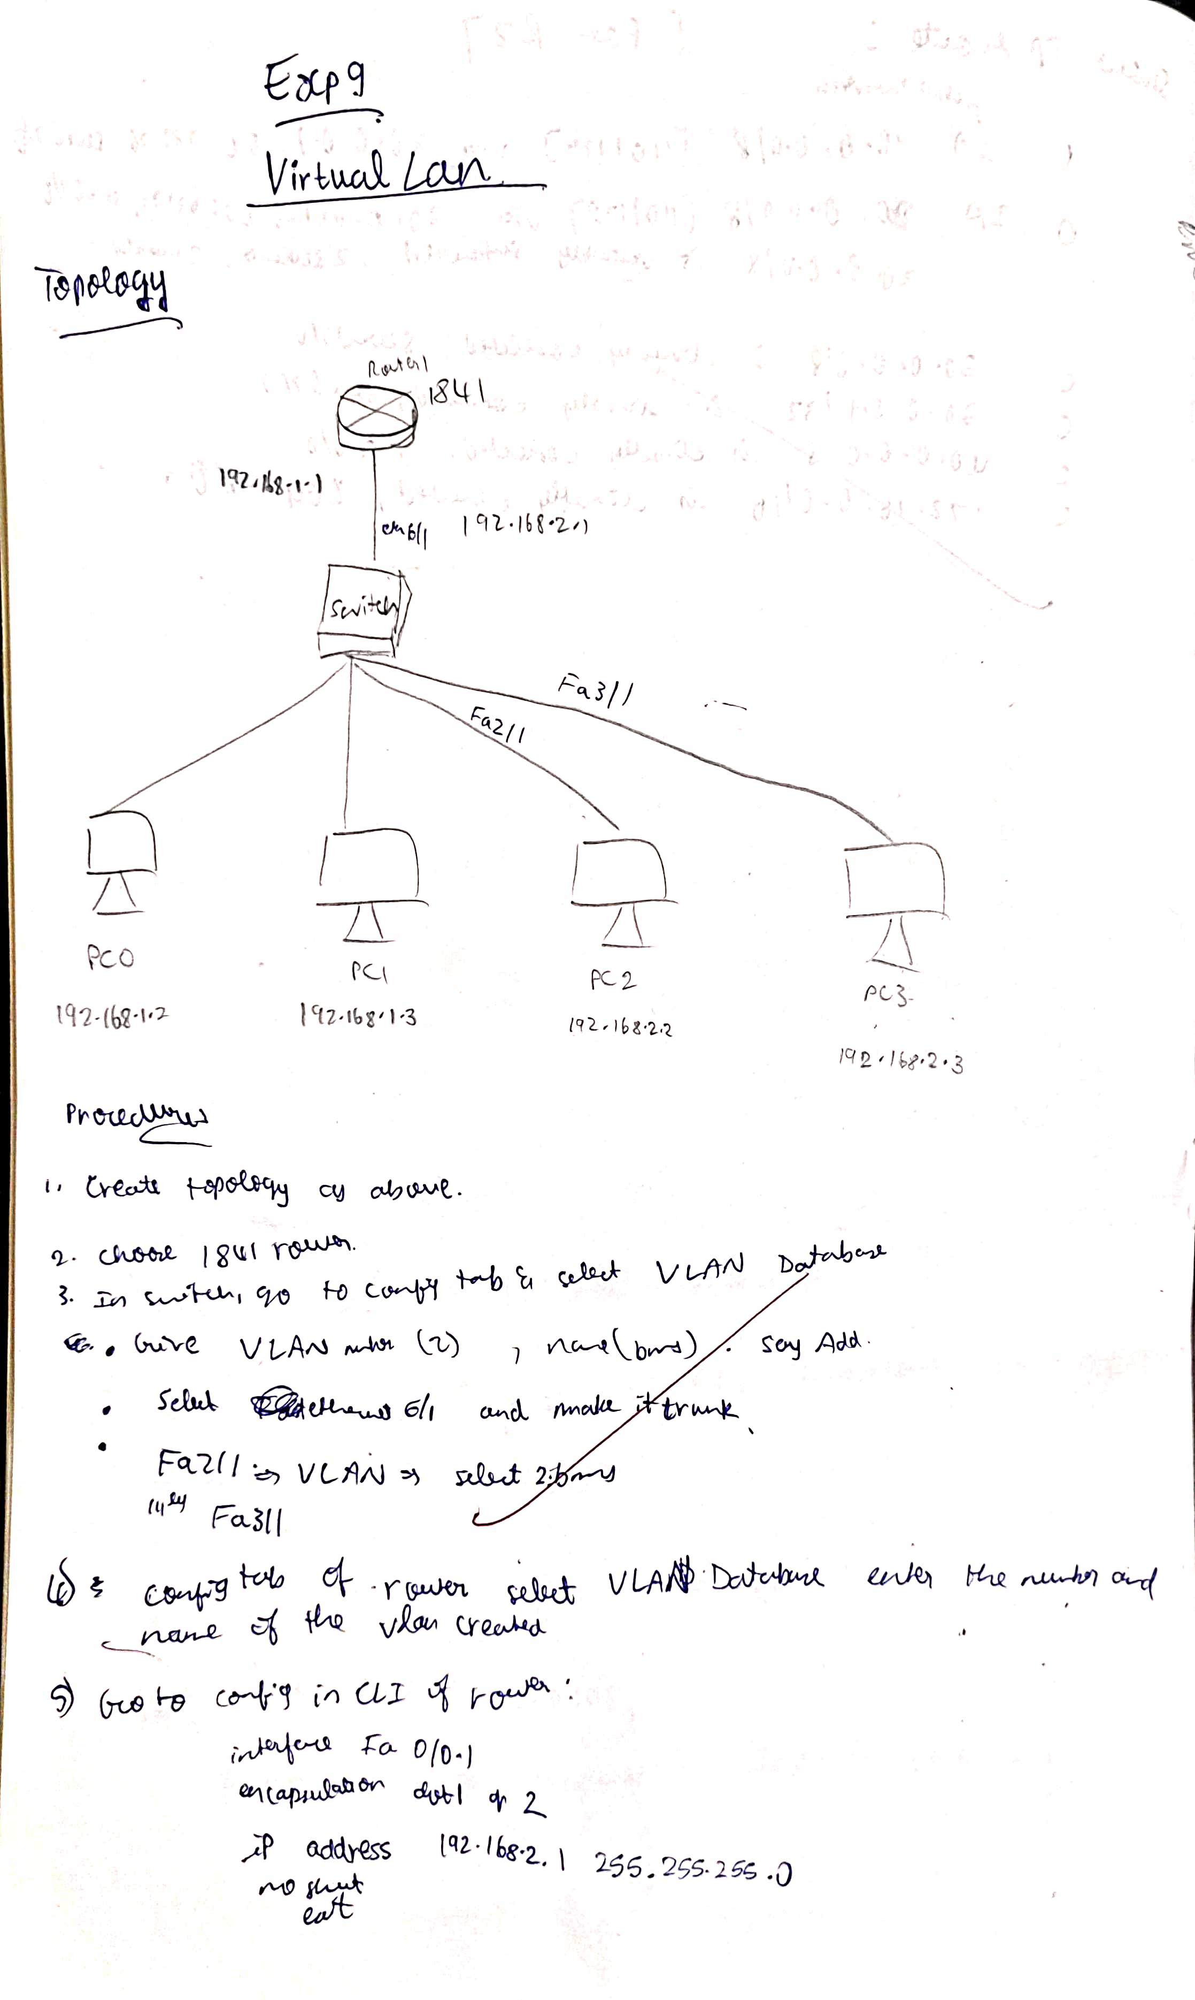

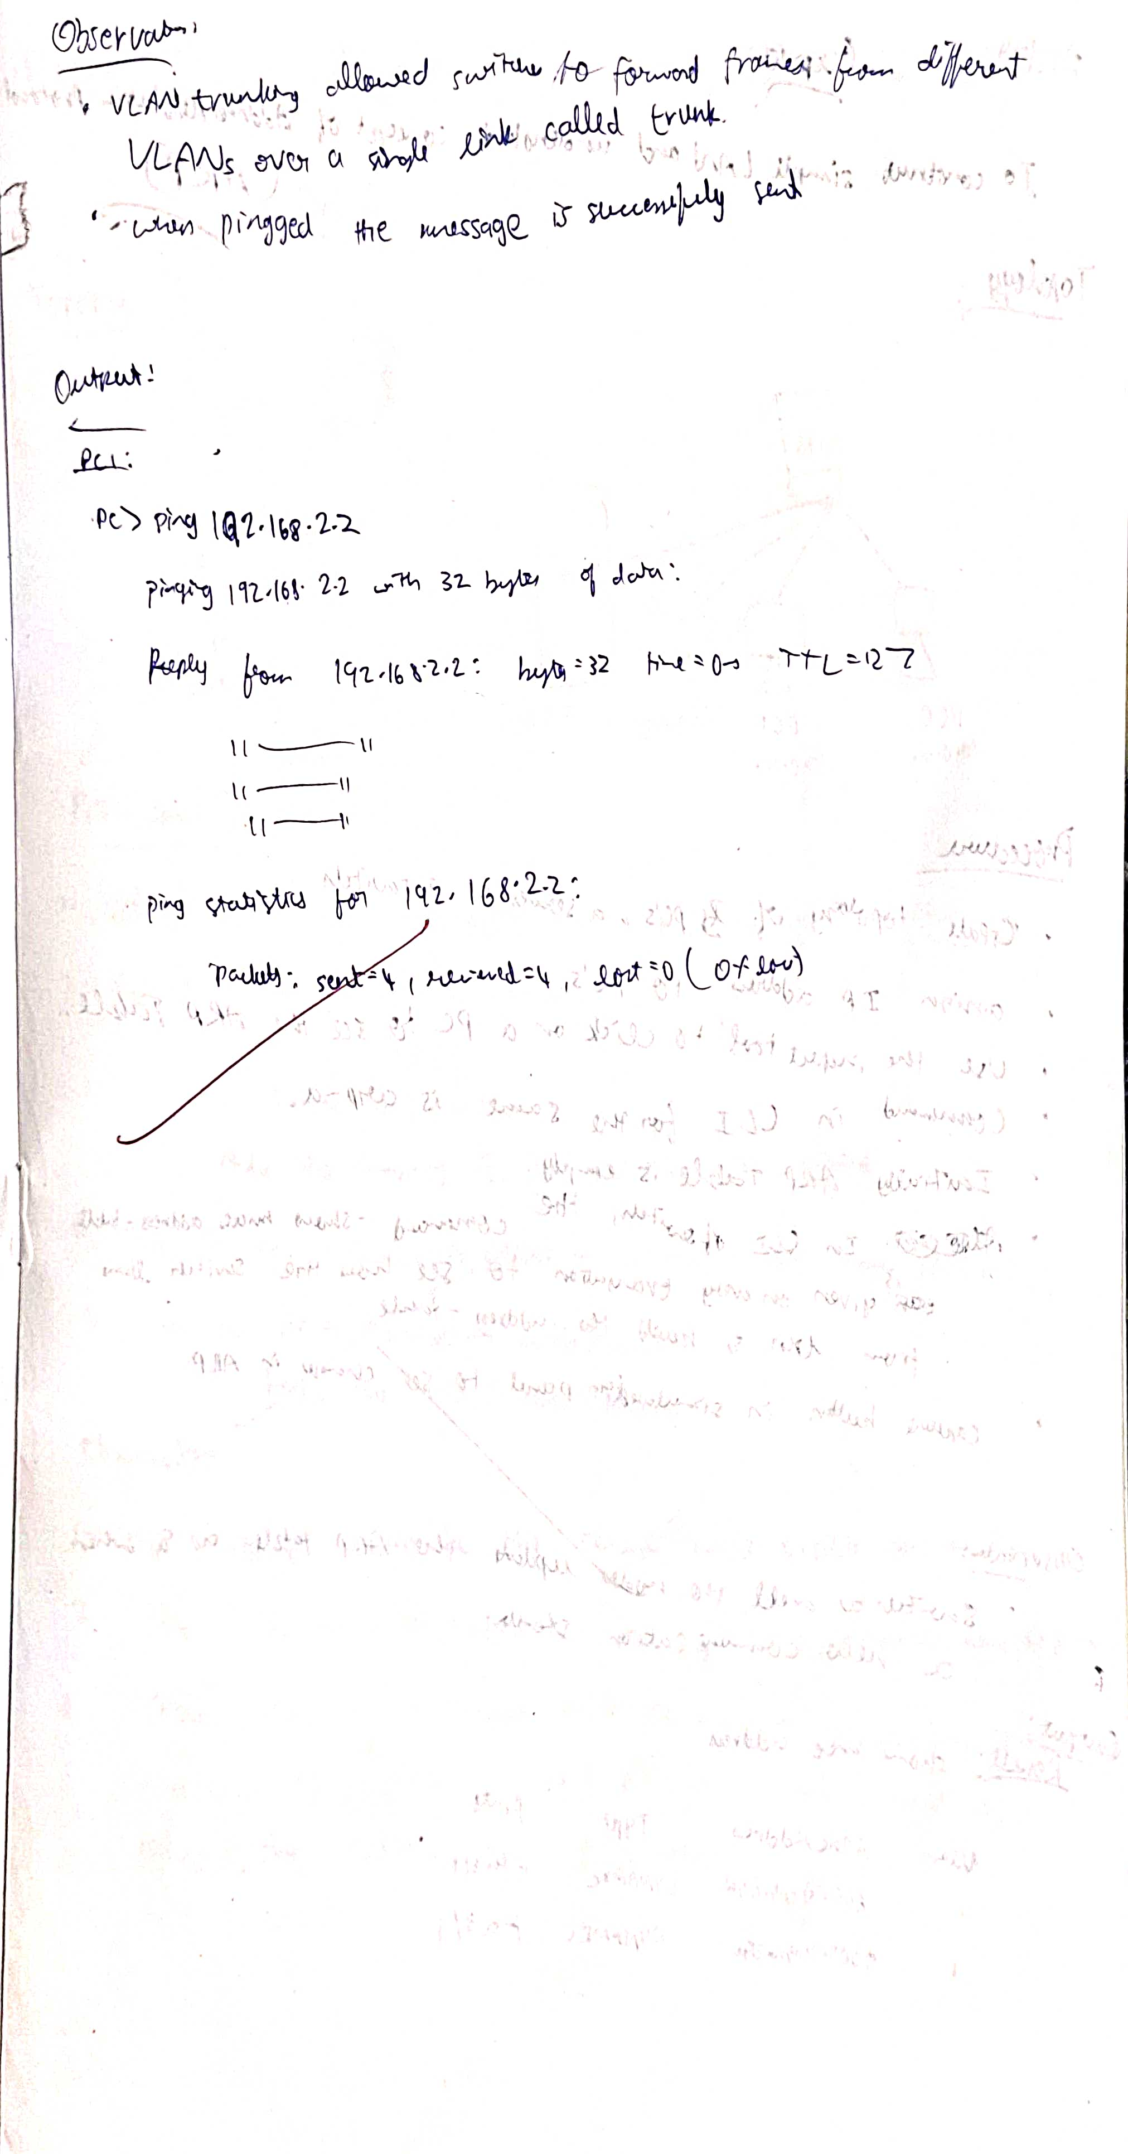

**Screen Shots:**

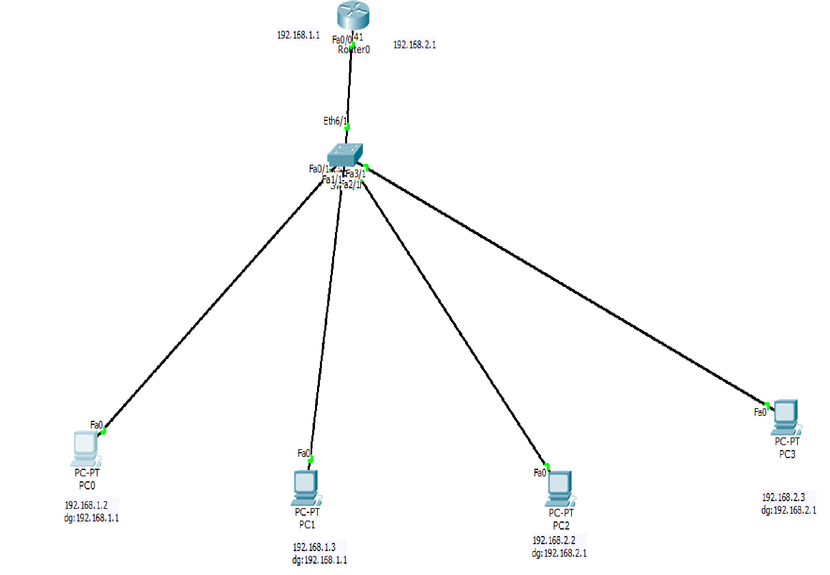

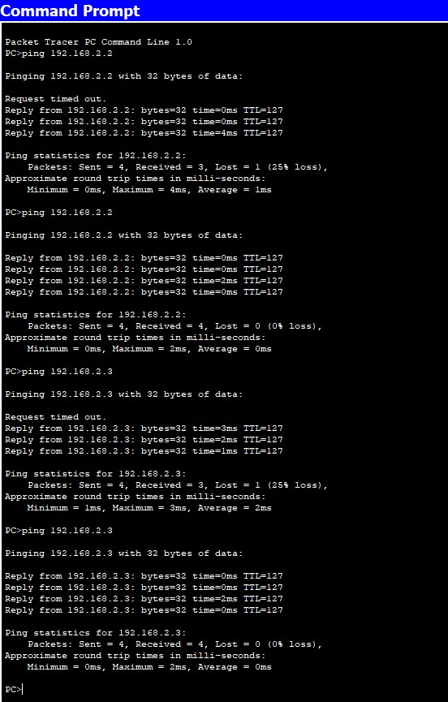

#### Program 13

**Aim:**To construct a WLAN and make the nodes communicate wirelessly.

**Topology , Procedure and Observation:**

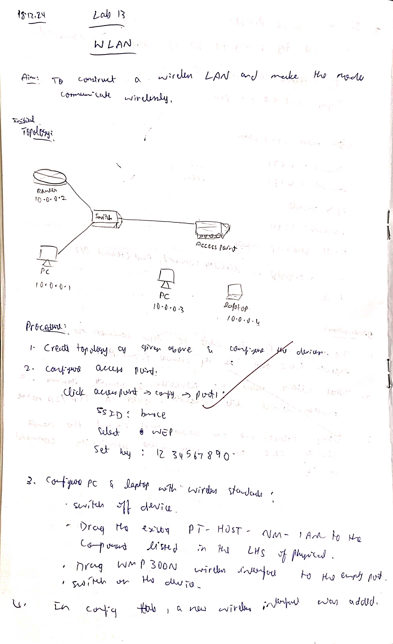

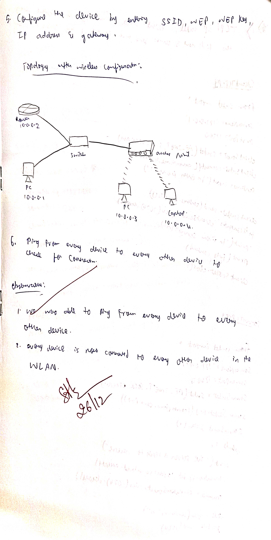

**Screen Shots:**

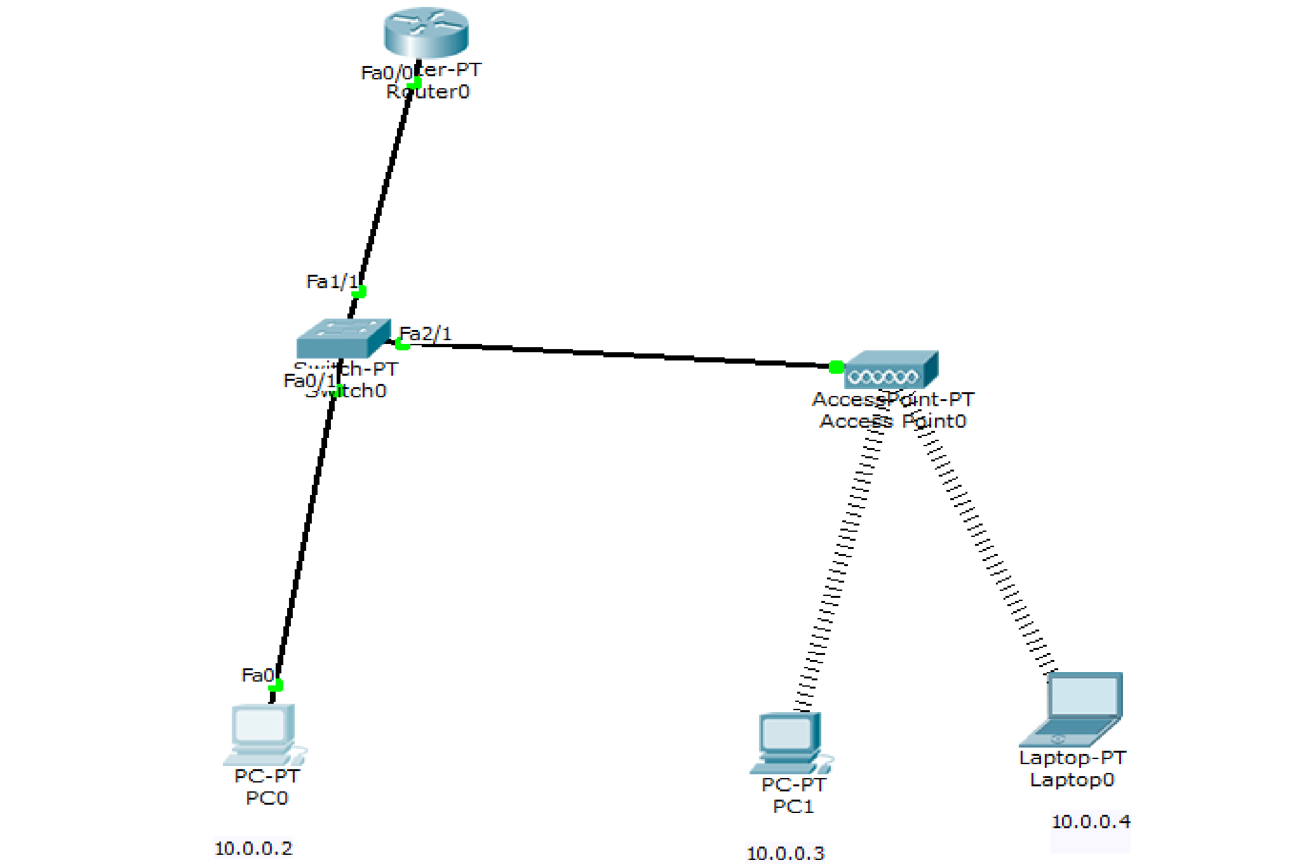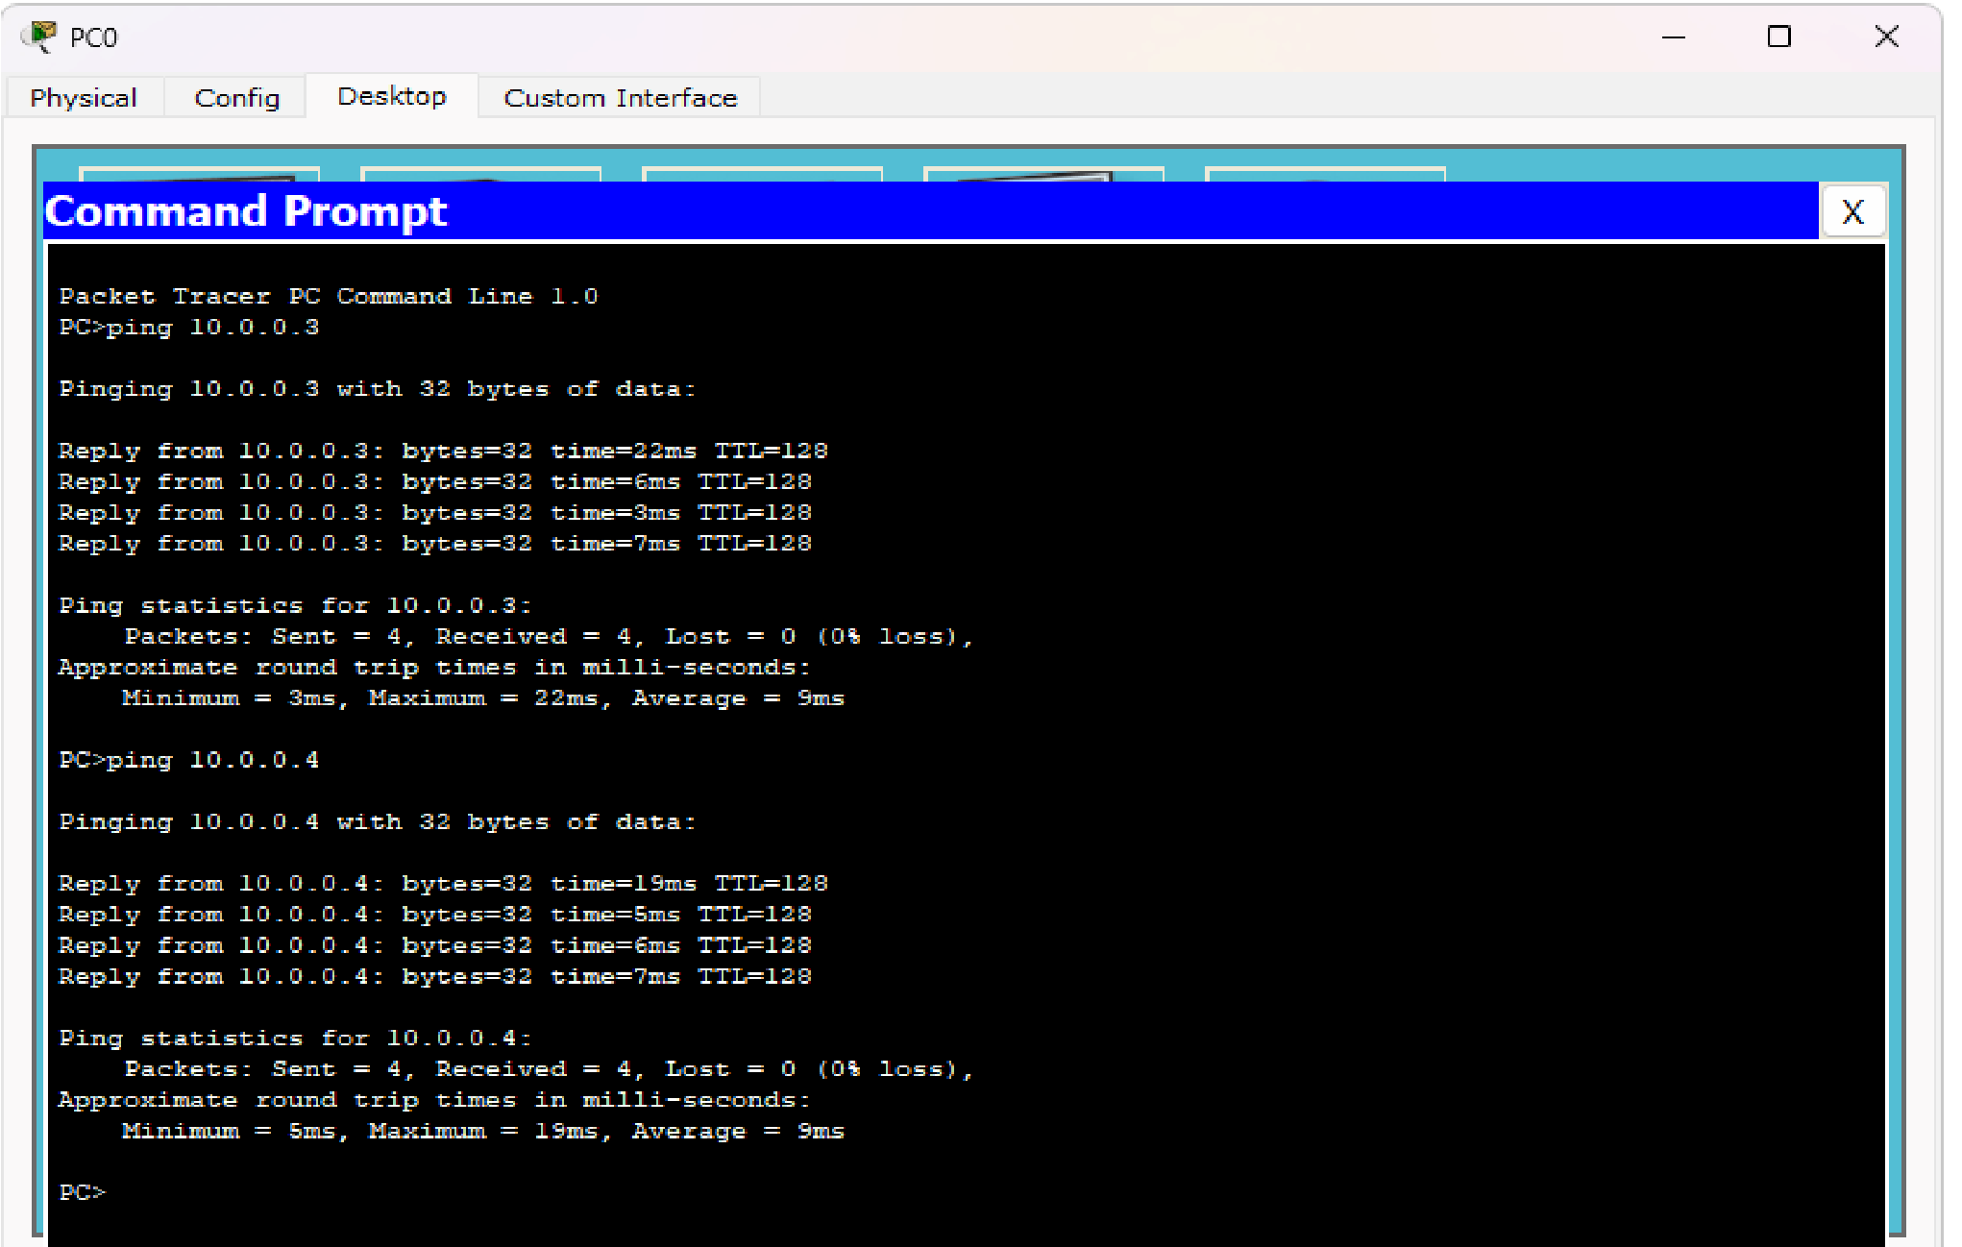

### PART-B

#### Program 14

Write a program for error detecting code using CRC-CCITT (16-bits).

**Code :**

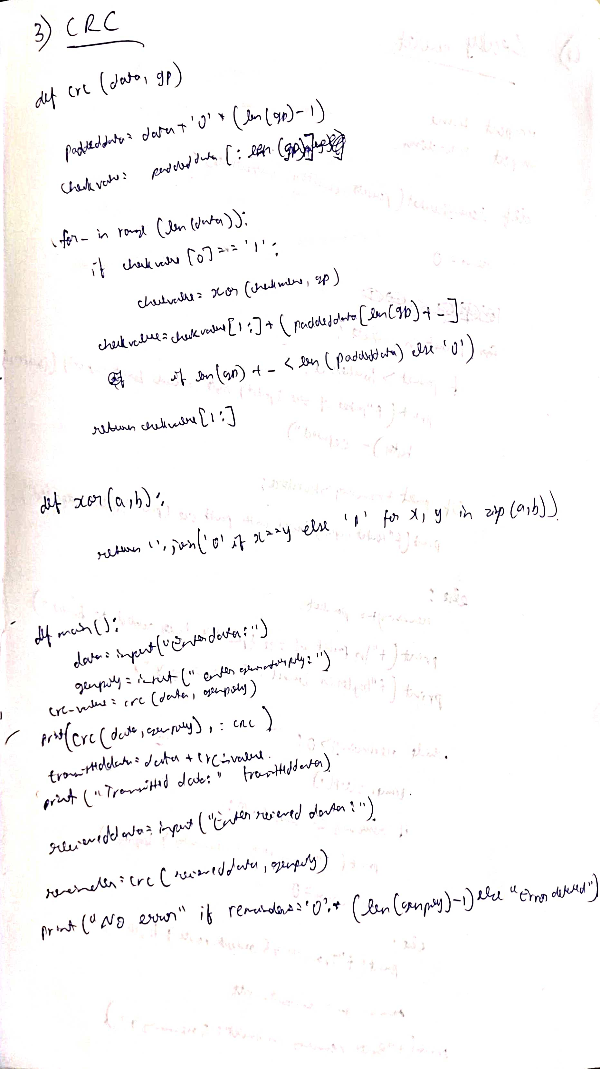

#### 

#### Program 15

Write a program for congestion control using Leaky bucket algorithm.

**Code :**

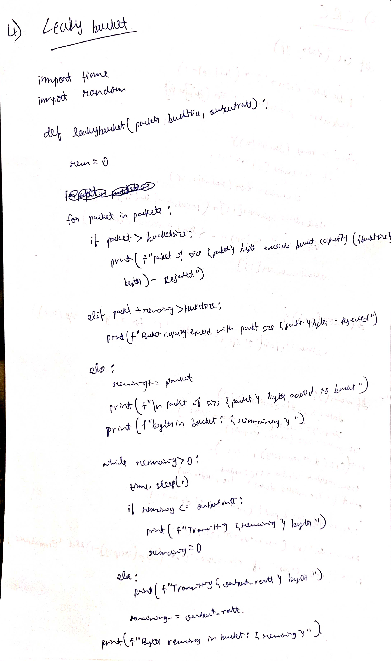

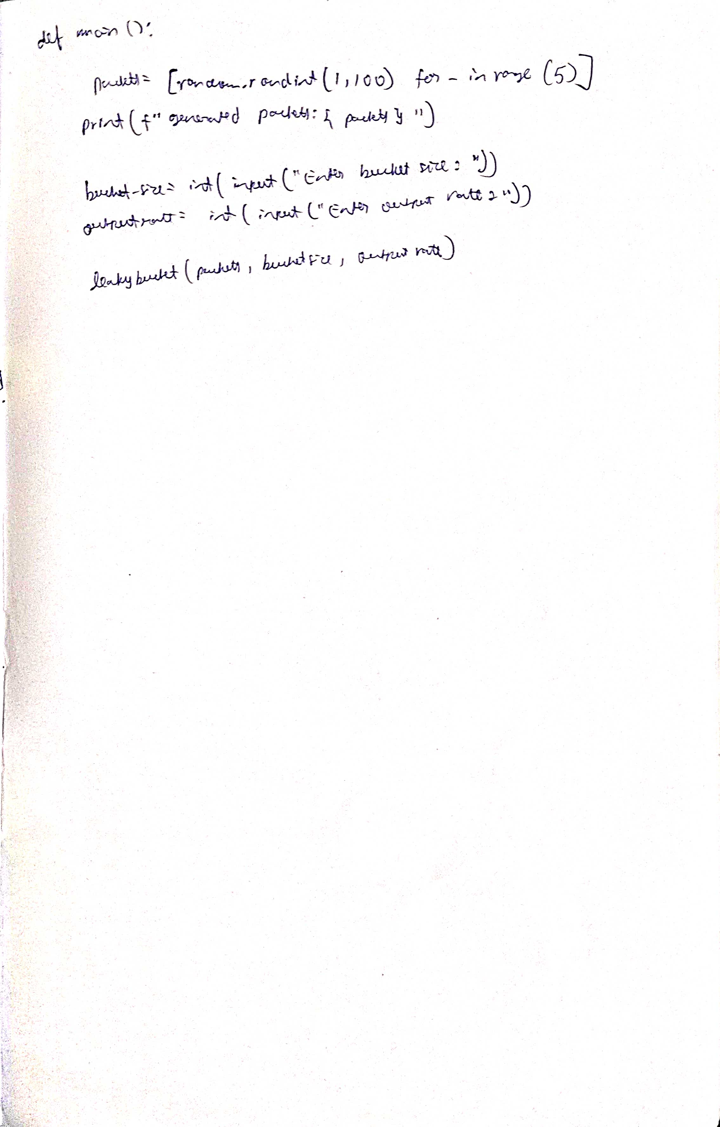

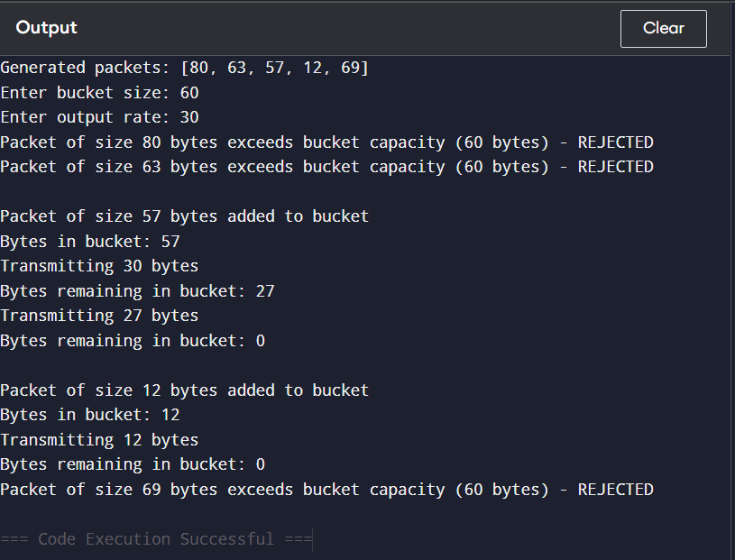

#### Program 16

Using TCP/IP sockets, write a client-server program to make the client send the file name and the server to send back the contents of the requested file if present.

**Code and Output:**

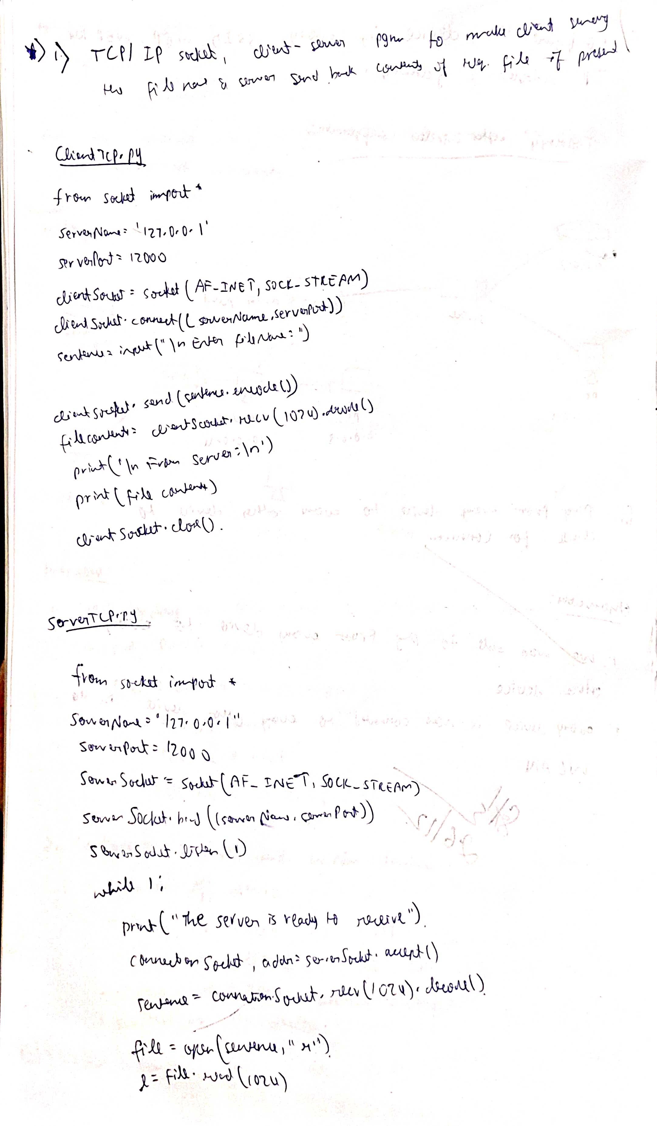

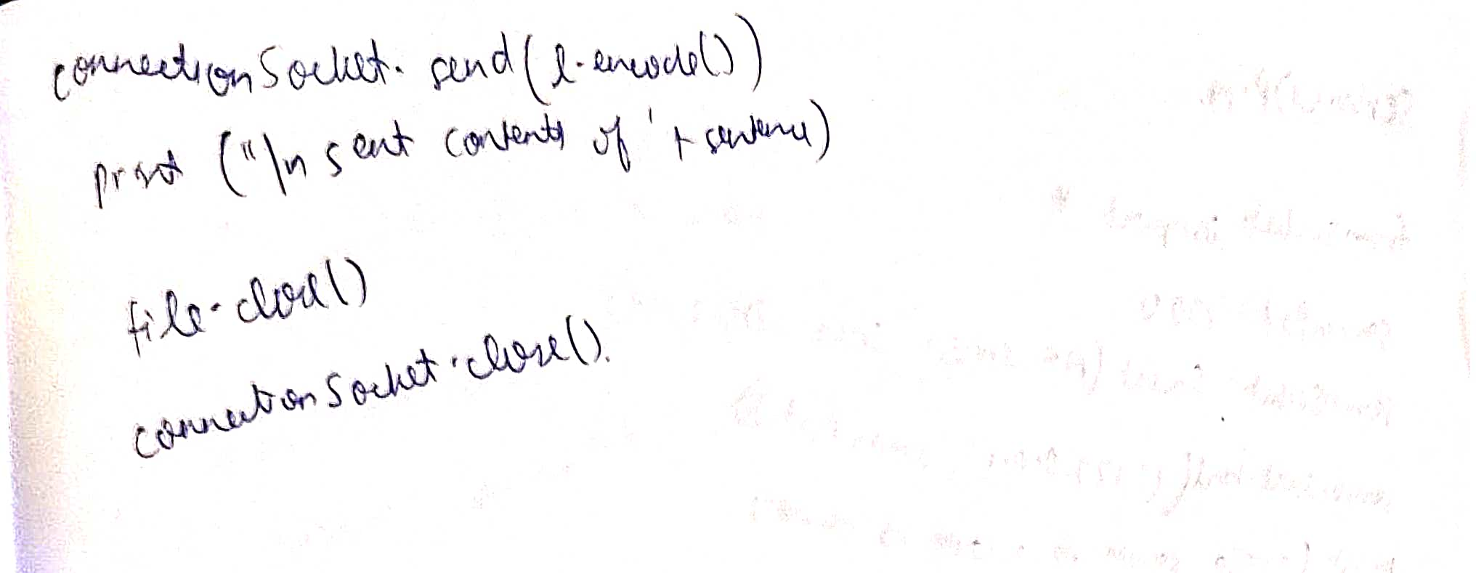

#### Program 17

Using UDP sockets, write a client-server program to make the client send the file name and the server to send back the contents of the requested file if present.

**Code and Output:**

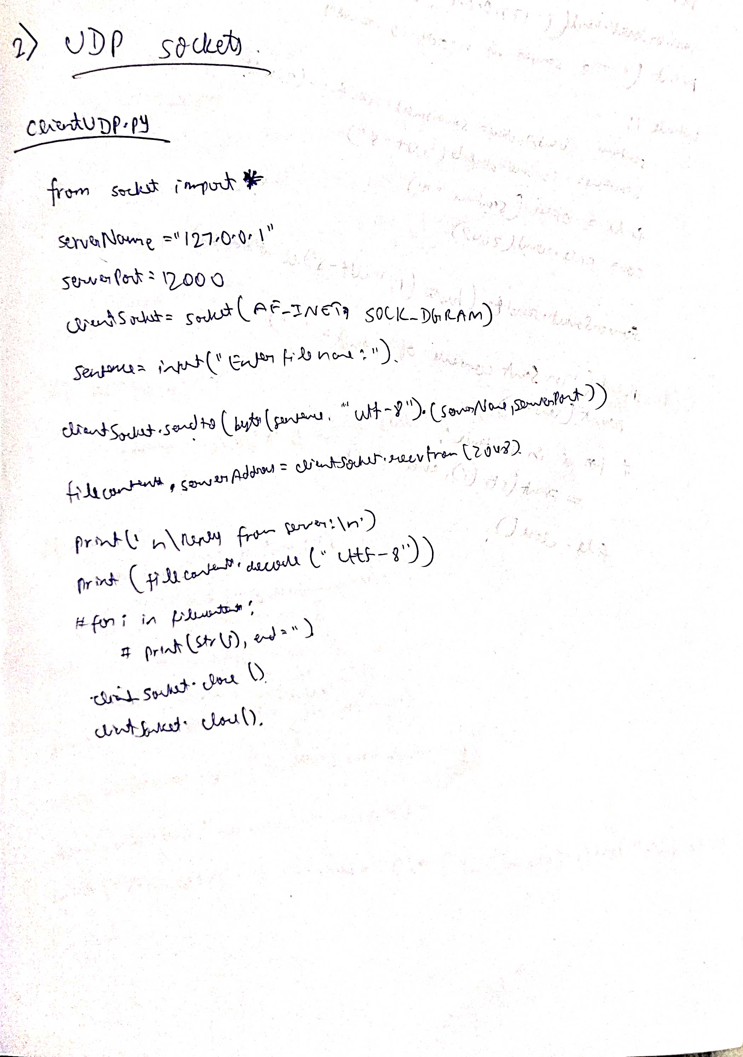

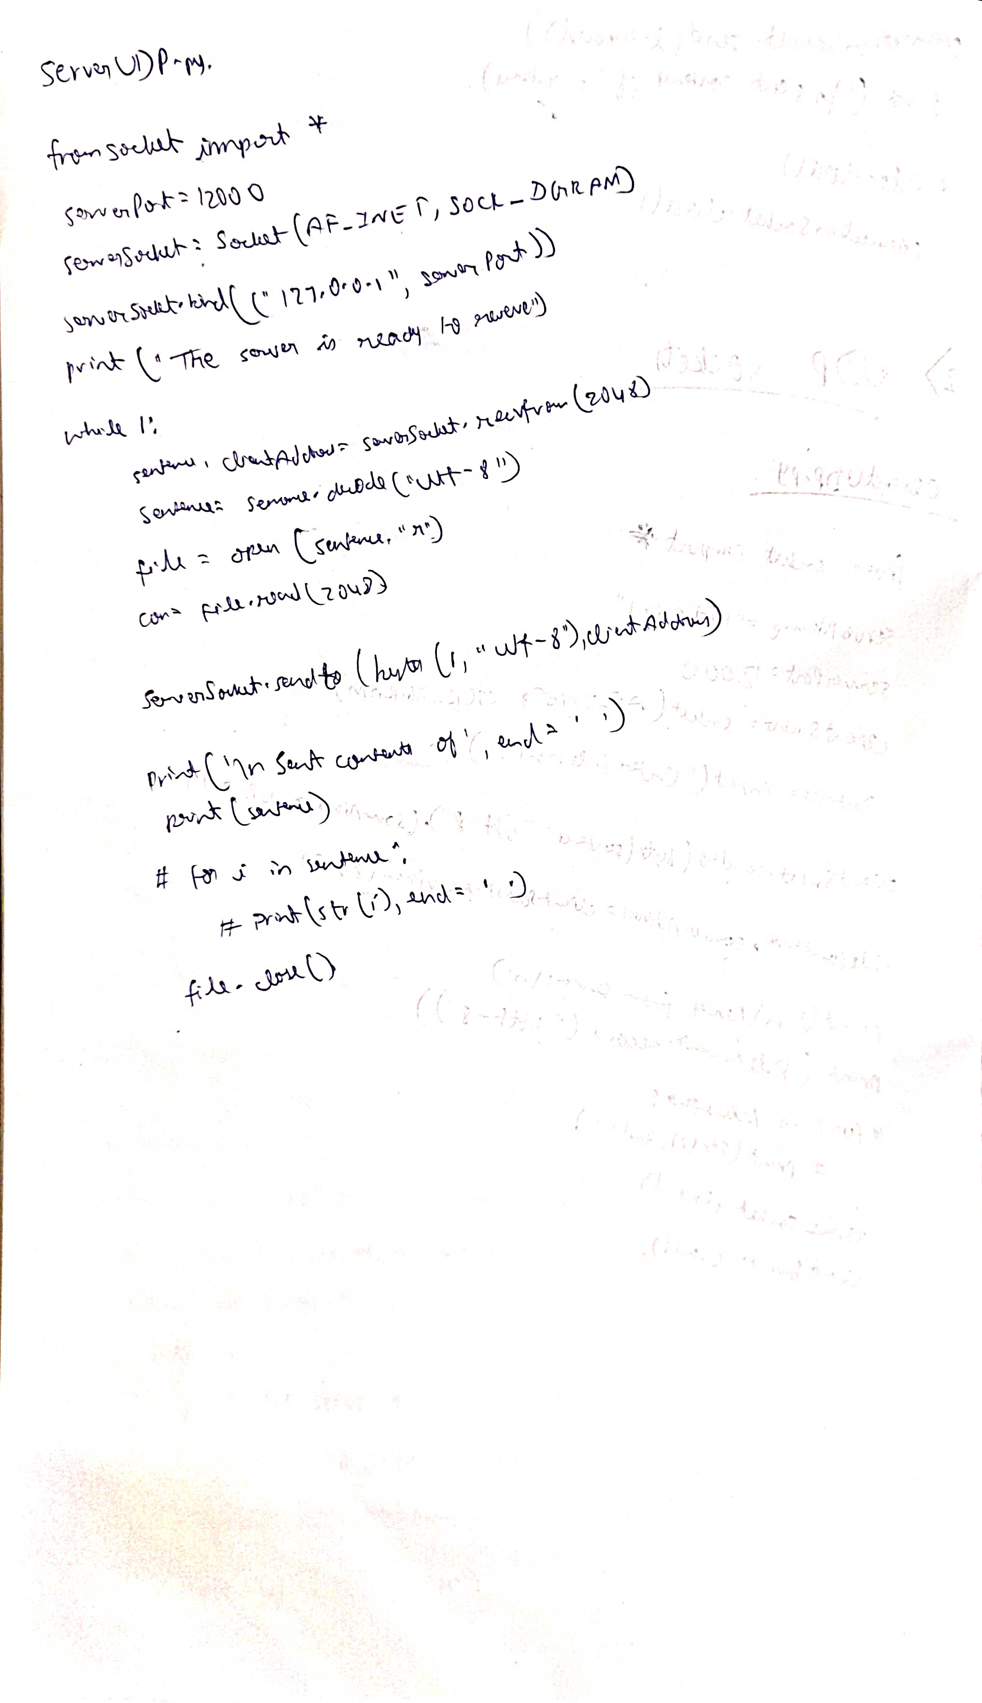

**WIRESHARK**



